16 states exceed emisson limits
Only eleven member states expect to comply with their emission limits for all four air pollutants set by the EU national emission ceilings directive.
Sixteen EU countries are likely to exceed national limits on emissions of at least one of four key air pollutants set for 2010, according to an analysis carried out by the European Environment Agency (EEA).
The national emission ceilings directive (NEC) sets pollutant-specific and legally binding emission ceilings for each member state to meet by 2010. It requires the countries to submit annual reports on emissions and projections for four air pollutants: sulphur dioxide (SO₂), nitrogen oxides (NO_{x}), volatile organic compounds (VOCs) and ammonia (NH3).
EEA’s analysis is based on figures reported by member states, including final data for 2005, preliminary data for 2006 and projected emissions in 2010. Only eleven member states anticipate they will meet all four emission ceilings, while fifteen states indicate they will miss at least one of their respective ceilings. One member state – Luxembourg – did not provide any emission projections.
Nitrogen oxides continue to pose the greatest challenge, with thirteen member states predicting they will miss their national tional ceilings for 2010. NO_{x} emissions for the EU27 as a whole are still projected to be nine per cent above the aggregated member state limits (known as the Annex I ceiling) and 20 per cent above the stricter ceiling for the EU as a whole (the Annex II ceiling) set for 2010.
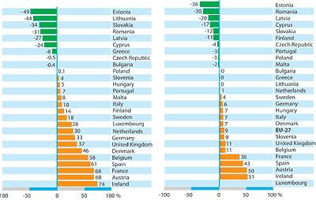
Distance to NO_{x} emission ceilings for countries’ emission levels in the year 2006
Over the period 1990–2006 emissions rose in four countries: Cyprus, Greece, Portugal and Spain. The largest single polluter was the UK, which alone accounted for nearly 15 per cent of the total emissions. Germany, Spain and France each contributed about 12 per cent. The shortfall in reaching the ceilings in absolute terms is largest for Spain (364 kilotonnes), France (295 kt) and the UK (127 kt), and in relative terms for Ireland (whose 2006 NO_{x} emissions were 74% above the 2010 ceiling), Austria (68%), France (68%) and Spain (61%).
Even taking into account NO_{x} control measures already in place within the member states, some states including the Netherlands, Sweden and Germany expect to emit only slightly more NO_{x} than their ceilings. Others, such as Ireland, Austria and Spain, are projected to miss substantially their targets by as much as 50 per cent.
According to the EEA, higher than expected growth in road transport is
partly to blame. Moreover, the eff ectiveness of certain vehicle emission controls measures, especially the Euro II and Euro III standards for heavy-duty vehicles, turned out to be smaller than originally anticipated. Despite the fact that the lower than expected eff ectiveness of these control measures has been widely known since around 2002 or 2003, very few – if any – Member States seem to have taken the needed additional action to compensate for the shortfall. In fact several countries that expect to exceed their NO_{x} ceilings by 2010 have not reported on plans to implement additional measures that may allow them to comply with their 2010 ceilings. According to article 6:2 of the NEC directive, any country that is not on track should already have developed and presented such plans by 2006.
Regarding sulphur dioxide the Netherlands is the only country that does not expect, with the current measures in place, to meet its ceilings by 2010, although by implementing additional measures it anticipates meeting the ceiling in time. Between 1990 and 2006 all member states except Greece report a decrease in emissions. The biggest reductions were reported by Latvia (97%), Germany (90%), Hungary (88%), Denmark (86%), and Italy (77%). The major polluters were Poland and Spain, which contributed 15 and 14 per cent respectively of total emissions. The EU as a whole is projected to be 31 per cent below the aggregate ceiling and 27 per cent below the Annex II ceiling.
Five member states – Denmark, France, Poland, Portugal, and Spain – report that they do not envisage meeting their VOC ceilings in 2010. Two countries – Greece and Portugal – increased their emissions during the period 1990–2006. The biggest single polluters were Germany and France, each accounting for nearly 15 per cent of the total emissions. The projections for the EU as a whole are nine per cent below the aggregated ceiling target of Annex I, but six per cent above the Annex II ceiling.
Twenty member states have already reduced ammonia emissions below their respective ceilings for 2010. Germany and Spain report that they will not reach the target for 2010 with the current measures in place. The projections for the EU27 are seven per cent below the aggregated EU emission ceiling. Inadequate reporting by several countries makes comparisons and forecasts for the EU as a whole unreliable. Amongst the fourteen member states that provided emission estimates for the years 1990 and 2006, Italy, Spain and Cyprus report increased emissions, whilst all other countries reported decreases.
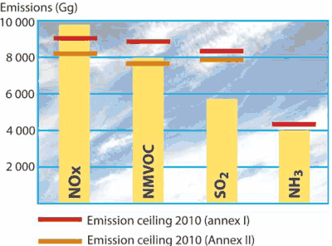
Aggregated “with measures” projected emissions for 2010 reported by Member States compared with the EU27 combined emission ceilings as given in Annex I and Annex II of the NEC directive.
Only eighteen out of 27 member states met the required reporting deadline of 31 December 2007. Ten countries provided additional or revised data between January and July 2008. Only nine member states submitted emission inventories in a comparable and consistent format, while the remaining eighteen states submitted data using a variety of non-standard formats. To help improve transparency, the EEA suggest that future reporting by member states could include a short informative report with explanatory information. It also suggests that a definition of formats for emission inventory reporting should be included in the forthcoming revised NEC directive.
Based on its Thematic Strategy on Air Pollution from September 2005, the European Commission spent nearly three years preparing a proposal for a revised NEC directive – the main intention being to set new (stricter) emission ceilings for 2020, and expand the number of air pollutants covered from four to five by adding fine particles (PM2.5). For various reasons the proposal has been postponed several times, and in June 2008 the Commission had a draft proposal ready, but decided again to postpone (see AN 3/08). The Commission has so far failed to explain why the draft new legislation was again delayed or when it is expected to be published.
Christer Ågren
NEC Directive status report 2007. EEA Technical report No. 9/2008. Published by and available from the European Environment Agency. See: http://www.europa.eu/publications/technical_report_2008_9
The NEC directive
The aim of the NEC directive is to limit emissions of acidifying and eutrophying pollutants and ozone precursors in order to improve the protection in the EU of the environment and human health against risks of adverse effects from acidification, soil eutrophication and ground-level ozone.
National emission ceilings for four pollutants – sulphur dioxide (SO₂), nitrogen oxides (NO_{x}), volatile organic compounds (VOCs), and ammonia (NH₃) – are specified with the objective of achieving a range of interim environmental objectives by 2010 compared to a 1990 baseline.
Annex I of the NEC directive defines both country-based ceilings and aggregated emission ceilings for the EU27 (which are the sums of the individual Member State ceilings in that Annex). Annex II also defines ceilings for the EU27 as a whole, but only for three of the four pollutants (SO₂, NO_{x} and VOCs). These ceilings are stricter than those in Annex I and are designed with the aim of attaining by 2010 the interim environmental objectives set out in the directive.
The directive requires Member States to report information concerning emissions of the four pollutants. The states shall also report expected trends until 2010, the year in which they are to meet their undertakings.
More information on the directive:
- European Commission
- Factsheet from the Secretariat (2004)

