http://pmr.uoregon.edu/science-and-innovation/uo-research-news/research-news-2008/september-2008/climate-change-human-activity-and-wildfires-1/

University of Oregon

Climate change, human activity and wildfires

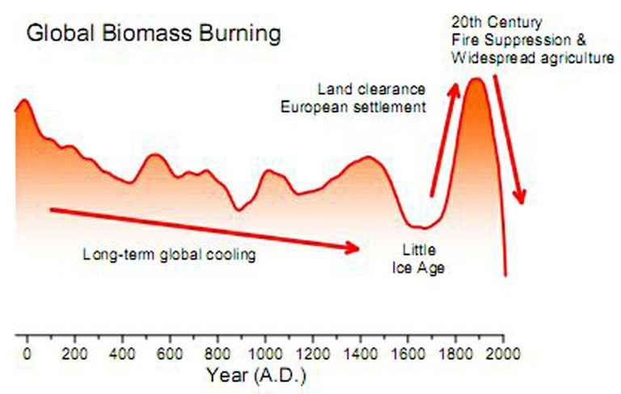
UO-led study of last 2,000 years of charcoal evidence suggests human impacts have curtailed fires in most areas

EUGENE, Ore. -- (Sept. 21, 2008) -- Climate has been implicated by a new study as a major driver of wildfires in the last 2,000 years. But human activities, such as land clearance and fire suppression during the industrial era (since 1750) have created large swings in burning, first increasing fires until the late 1800s, and then dramatically reducing burning in the 20th century.

The study by a nine-member team from seven institutions -- led by Jennifer R. Marlon, a doctoral student in geography department at the University of Oregon -- appears online ahead of regular publication in the journal Nature Geoscience. The team analyzed 406 sedimentary charcoal records from lake beds on six continents.

A 100-year decline in wildfires worldwide -- from 1870 to 1970 -- was recorded despite increasing temperatures and population growth, researchers found. "Based on the charcoal record," Marlon said, "we believe the reduction in the amount of biomass burned during those 100 years can be attributed to a global expansion of agriculture and intensive grazing of livestock that reduced fuels plus general landscape fragmentation and fire-management efforts."

Above a 2006 wildfire burns boreal forests in the Yukon Flats, central Alaska. The photo was taken by Phil Higuera. Below is a post-wildfire view of the 1996 Charlton burn near Waldo Lake in the central Oregon Cascades. (Bottom photo, copyright Jennifer Marlon)

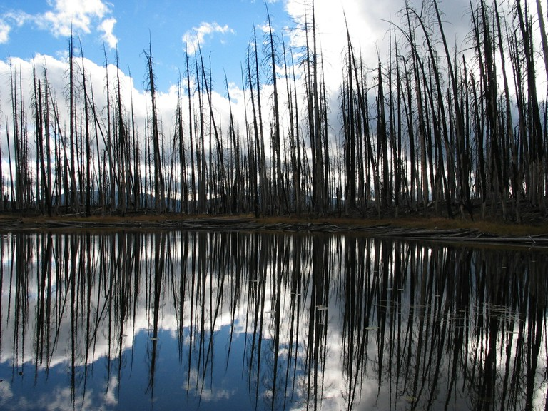

Observations of increased burning associated with global warming and fuel build-up during the past 30 years, however, are not yet included in the sediment record.

Charcoal levels have drawn attention during the past 25 years because these data can track wildfire activity -- both incidence and severity -- over long time periods, providing information when similar data from satellites or fire-scarred trees do not exist. This study is among early efforts to analyze charcoal records for widespread patterns and trends over such a long period.

The importance of the data presented by Marlon's team is put into perspective of overall information about the history of wildfires in a "News & Views" article, also appearing online, written by Andrew C. Scott, an earth sciences researcher at the University of London.

During the last 2,000 years, fire activity was highest between 1750 and 1870. "This was a period when several factors combined to generate conditions favorable to wildfires," Marlon said. "Population growth and European colonization caused massive changes in land cover, and human-induced increases in atmospheric carbon dioxide concentrations may have started to increase biomass levels and fuels."

From A.D. 1 to about 1750, wildfires worldwide declined from earlier years, probably resulting from a long-term global cooling trend that offset any possible influence of population growth and related land-use changes. Researchers pointed to charcoal evidence in western North America as an example of this trend. Similar records also were found in Central America and tropical areas of South America. In the western U.S. and in Asia, researchers noted, "initial colonization may have been marked by an increased use of fire for land clearance.”

Subsequently, expansion of intensive agriculture and grazing, as well as forest management activities, likely reduced wildfire activity, Marlon said. "Our results strongly suggest that climate change has been the main driver of global biomass burning for the past two millennia," the researchers concluded. "The decline in biomass burning after A.D. 1870 is opposite to the expected effect of rising carbon dioxide and rapid warming, but contemporaneous with an unprecedentedly high rate of population increase."

The eight co-authors with Marlon were: Patrick J. Bartlein and Daniel G. Gavin, professors in the geography department and members of the Environmental Change Research Group; C. Carcaillet of the Centre for Bio-Archaeology and Ecology in Montpellier, France; S.P. Harrison and I.C. Prentice, both of the University of Bristol in the United Kingdom; P.E. Higuera of Montana State University in Bozeman, Mont.; F. Joos of the Physics Institute and Oeschger Centre for Climate Change Research in Bern, Switzerland; and Mitchell .J. Power of the University of Utah in Salt Lake City and a curator at the Utah Museum of Natural History.

The National Science Foundation in the United States and Natural Environment Research Council in the United Kingdom funded the research.

About the University of Oregon

The University of Oregon is a world-class teaching and research institution and Oregon's flagship public university. The UO is a member of the Association of American Universities (AAU), an organization made up of 62 of the leading public and private research institutions in the United States and Canada. Membership in the AAU is by invitation only. The University of Oregon is one of only two AAU members in the Pacific Northwest.

Media Contact: Jim Barlow, director of science and research communications, 541-346-3481, jebarlow@uoregon.edu

Sources: Jenn Marlon, doctoral student, geography, 203-507-2462, jmarlon@uoregon.edu; Patrick Bartlein, professor of geography, 541-346-4967, bartlein@uoregon.edu

Climate and human influences on global biomass burning over the past two millennia

J. R. Marlon1, P. J. Bartlein1, C. Carcaillet2, D. G. Gavin1, S. P. Harrison3, P. E. Higuera4, F. Joos5, M. J. Power6 & I. C. Prentice7

Nature Geoscience, Published online: 21 September 2008 | doi:10.1038/ngeo313
http://www.nature.com/ngeo/journal/vaop/ncurrent/abs/ngeo313.html

Abstract

Large, well-documented wildfires have recently generated worldwide attention, and raised concerns about the impacts of humans and climate change on wildfire regimes. However, comparatively little is known about the patterns and driving forces of global fire activity before the twentieth century. Here we compile sedimentary charcoal records spanning six continents to document trends in both natural and anthropogenic biomass burning for the past two millennia. We find that global biomass burning declined from AD 1 to 1750, before rising sharply between 1750 and 1870. Global burning then declined abruptly after 1870. The early decline in biomass burning occurred in concert with a global cooling trend and despite a rise in the human population. We suggest the subsequent rise was linked to increasing human influences, such as population growth and land-use changes. Our compilation suggests that the final decline occurred despite increasing air temperatures and population. We attribute this reduction in the amount of biomass burned over the past 150 years to the global expansion of intensive grazing, agriculture and fire management.

--------------------------------------------------------------------------------

Department of Geography, University of Oregon, Eugene, Oregon 97403, USA
Centre for Bio-Archaeology and Ecology (UMR5059 CNRS/UM2/EPHE), Institut de Botanique, F-34090 Montpellier, France

School of Geographical Sciences, University of Bristol, Bristol BS8 1SS, UK
Department of Earth Sciences, Montana State University, Bozeman, Montana 59717, USA

Climate and Environmental Physics, Physics Institute and Oeschger Centre for Climate Change Research, University of Bern, CH-3012 Bern, Switzerland

Utah Museum of Natural History, Department of Geography, University of Utah, Salt Lake City, Utah 84112, USA

QUEST, Department of Earth Sciences, University of Bristol, Bristol BS8 1RJ, UK
Correspondence to: J. R. Marlon1 e-mail: jmarlon@uoregon.edu

