Acid News, Oct 2009
Island states demand 95 per cent emission cuts
Island states and least developed countries agree: Rich nations have caused the problem, and should cut emissions 95 per cent by 2050.
The rich countries need to cut greenhouse gas emissions 95 per cent by 2050, 40 per cent by 2020.
So says the Alliance Of Small Island States (AOSIS), which recently joined forces with the Group Of Least Developed Countries (G-LDCs) in demands for further commitment under the Climate Convention and Kyoto Protocol.
In a press statement on August 141, the joint group of 80 nations, with a population of about 800 million people2 asked for
- a return to 350 ppm of CO₂
- a maximum temperature increase of as far below 1.5 degrees as possible.
- that global emissions peak by 2015 and are reduced by at least 85 per cent below 1990 levels by 2050.
- that rich nations (Annex I) must reduce their emission 40 per cent by 2020.
According to the AOSIS-LDC, the pledges from Annex I countries amount to no more than 10–16 per cent reduction from 1990 to 2020. (After the Japanese election this figure has improved somewhat.)
This would, according to AOSIS-LDC “risk taking us on a path to temperature increase in excess of 3 degrees of pre-industrial levels. Such a level would be catastrophic for all countries."
"Recent studies show that the cost for developed nations of achieving a 40 per cent reduction is as low as 0.5 to 1.5 per cent of GDP by 2020. This is a small price to pay when compared to the anticipated skyrocketing costs for developing countries to adapt to a warmer world,” said Dessima Williams, UN representative for Grenada and chair of AOSIS, in the press statement.
Bruno Sekholi, from Lesotho and chair of the LDC group added:
"We will not allow negotiators and governments to ignore the human cost of climate change: hunger, disease, poverty and lost livelihoods are all on our doorstep. These impacts have the potential to threaten social and political stability, and in some cases the very survival of low-lying island states."
Two other documents from AOSIS in March 1, presented by Grenada and Tuvalu for the Climate Convention, elaborate on the issue of attribution, and point to the fact that rich countries have a much greater historical responsibility. The CO₂ build-up in the atmosphere originates primarily from them.
All nations have a responsibility for where we are, but some more, very much more than others.
The documents refer to data for accumulated CO₂ from combustion (1850–2005) and deforestation (1950–2000), with striking results.
Of all human CO₂ so far, the United States has contributed 29.25 per cent or 328,264 megatons, whereas Annex I parties to the climate convention, including the United States, have contributed about 75 per cent of the accumulated emissions 1850–2005, and the developing nations only 25 per cent.
A closer look at the table shows even more disparity. The bottom half of the table (93 nations) have contributed 7.8 gigatons or 0.7 per cent of the emissions. These include nations with large populations, for example the two Congos.
Luxemburg, with a population of a half million, has emitted more CO₂ in absolute terms than Bangladesh, with a population of 153 million.
It should also be noted that there are some wealthy nations in the non-Annex I group: South Korea, Singapore, Brunei, Quatar, Kuwait and Israel are all high-emitters and have a large GDP per capita. On the other hand, some of the Annex I nations are far from rich.
The discrepancy between emissions from Annex I and non-Annex I, though large, is actually a blurred version of the very crisp rich-poor divide. This contrast between emissions from the rich and the poor obviously deepens much further if differences between income groups within nations are accounted for, though that does not show in the UN data.
If the rich are the cause of global warming, the effects are disproportionate in the other direction. The AOSIS-LDC refers to a report from May 2009 by the Global Humanitarian Forum3 led by Kofi Annan. It found that climate change already delivers global economic losses of US$125 billion per year, “with 90 per cent of the burden falling to developing countries.”
The impacts enumerated by AOSIS-LDC hit the poor nations worst, but by no means exclusively: “sea level rise, ocean acidification, coral bleaching, flooding, drought, desertification, loss of fresh water supplies, biodiversity loss and more frequent and intense weather events including hurricanes”.
The conclusion is that the Annex I parties collectively must reduce their emissions by more than 95 per cent from their 1990 levels by 2050.
The scientific basis for this is taken from IPCC. A stabilization concentration range of 445–490 ppm CO₂ equivalents (approximately equal to 350–400 ppm CO₂) is associated with a temperature increase of 2.0–2.4 degrees.
This is much too high, according to AOSIS. Even two degrees “would be devastating to the SIDS (small island developing states) and jeopardize the sovereign existence of many small island state parties to the (Climate) Convention and (Kyoto) Protocol”.
AOSIS also points to the fact that recent scientific studies indicate that more ambitious and urgent action is necessary, for example:
- On top of a 0.4–1.2 m sea level rise due to thermal expansion alone, there is a risk of “substantial and possibly rapid loss of ice from Greenland and Antarctica”. Loss of Greenland ice sheet would raise sea levels by 2–7 metres over centuries to millennia, and a global warming of 1.9–4.6 degrees could trigger this loss.
- Sea levels are rising faster than IPCC projected.
- West Antarctic ice sheet loss is accelerating.
- Arctic sea loss is outpacing IPCC projections.
- Greenland ice sheet rate of loss has accelerated in recent years beyond predictions.
- Since IPCC’s fourth assessment in 2007, many studies have found that climate change is happening more rapidly and impacting key natural systems more severely and earlier than projected.
AOSIS also calls for a more transparent and understandable mitigation effort: taking 1990 as the base year for everybody and everything, to “ensure that there is no reward for failure to meet earlier agreed Kyoto targets”.
The AOSIS documents mention the need for more money, “higher targets on both the mitigation and adaptation and finance fronts”. But the emphasis is overwhelmingly on the moral obligation of the rich countries to clean up their own act. Ambassador Williams:
“The window of opportunity is closing quickly. Copenhagen is the last chance to avoid a human tragedy.”

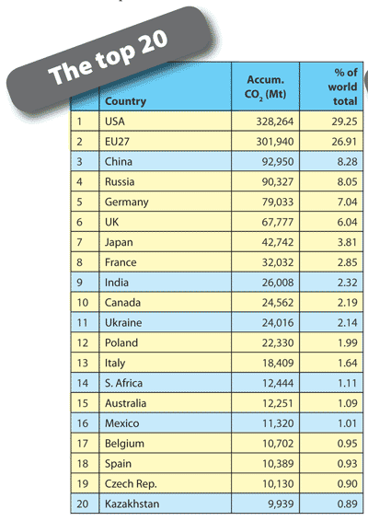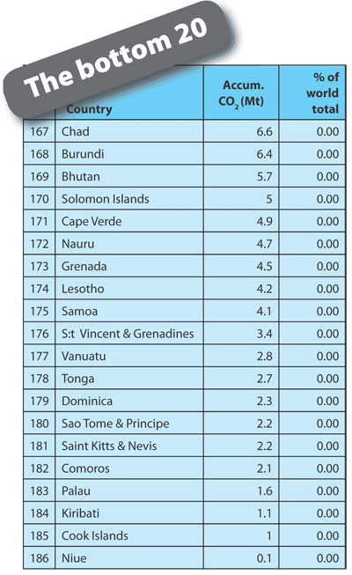
Table. [CLICK TO ENLARGE] Accumulated carbon dixode emissions (megatonnes) by country from fossil fuels 1850–2005 and from land use change 1950–2000. Global top 20 (left) and bottom 20 (right) nations. Yellow marked rows are Kyoto Annex 1 countries.
Source: cait.wri.org/ cait.php?page=cumul& mode=view
Fredrik Lundberg
1) unfccc.int/resource/docs/2009/awg7/eng/misc01a01.pdf
2) www.unohrlls.org/UserFiles/File/Publications/Factsheet.pdf
3) ghfgeneva.org/Portals/0/pdfs/human_impact_report.pdf

