Acid News, Oct 2009
Most rich Kyoto countries off track
Many rich countries will not be able to meet their climate commitments through active policy initiatives. Only “hot air” will do the trick.
Many countries that have made commitments under the Kyoto agreement will have problems meeting them. For most countries this will only be possible by resorting to “hot air”, such as pointing to falls in emissions that occurred in the ex-communist world after the fall of the Berlin wall, or largely unplanned changes in land use, or the CDM. The EU15 may be able to meet its commitments solely by means of measures taken at home.
The UN Climate Convention has summarised the changes in emissions that have taken place between 1990 and 2006 (see table 1, p. 3). The results hardly make encouraging reading. Emissions in the former communist countries (except for Slovenia) have fallen by 30–50 per cent, although this is clearly not due to active climate policy initiatives. The EU has achieved a small reduction of 2.2 per cent, while the total for the remaining Annex I countries (not counting the USA) is an increase of 13.8 per cent, with Australia, Canada and New Zealand showing an increase of more than 20 per cent.
The good news is that it is very likely that the Kyoto requirements can be met – if the former communist countries sell enough of their surplus.
The EU15 consists of those countries that were part of the union in 1997 and are signatories to the Kyoto Protocol.
The Annex I countries also include Turkey, which is a member of the OECD, but has still avoided any quantitative commitment. They also include the USA, which has signed but not ratifi ed the Kyoto Protocol. Emissions by these two countries have risen by 95 per cent and 14 per cent respectively.
If the USA had ratified Kyoto and committed to a reduction of seven per cent, but increased emissions as it has done, this would have meant a shortfall of 1,313 million tonnes (Mton) of carbon dioxide equivalents (CO2eq.) Even this could have been covered by the large surplus from Russia, the Ukraine and other states.
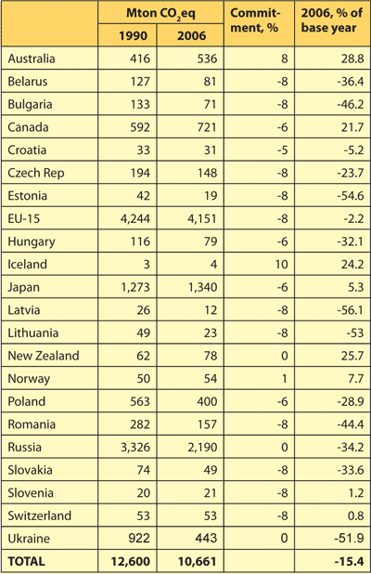
Table 1. Change in greenhouse gas emissions 1990–2006 in Annex I countries. The figures are not totally accurate. Firstly they do not take account of changes in land use. Secondly, all the figures are being readjusted continuously, including those for the base year. The base year is largely the same as emissions in 1990, although there may be some small deviations. Source: http://unfccc.int/resource/ docs/2008/sbi/eng/12.pdf)
At the time the Kyoto agreement was originally negotiated there were some murmurings of a recovery by heavy industry in the east following the slump. We now know that this was a lasting change in infrastructure. Whether intentional or not, the collective Kyoto undertaking effectively became little more than a redistribution of capital for emission reductions that had already been achieved.
The EU, which was the driving force behind the initial drafting of the Kyoto agreement and subsequently rescuing it after the USA’s withdrawal in 2001, has little to boast about either.
Breakdowns of figures are also available for the EU for 2007.
The EU’s reduction can partly be explained by the collapse of East German industry following reunification in 1990, which contributed to a fall in emissions of around 120 Mton in the early years of the 1990s, i.e. more than the entire reduction by the EU.
Other free reductions were achieved through reductions in agriculture, which led in turn to lower emissions of carbon dioxide, methane and nitrous oxide. Coal output was reduced purely for economic reasons, and on economic grounds alone would have been reduced even further if it were not for subsidies. Some older coal-fired power plants and steelworks were also closed for economic reasons.
Another factor was a reduction in methane emissions from landfill sites, a development that is only partly accountable to climate policy, but which is naturally welcome for the environment, energy conservation and fire safety. By 2007 emissions had almost halved, from 128 Mton CO2eq.
The two central items in the emissions budget, transport and power generation, both saw increases on the other hand. CO2 emissions from the power sector in the EU15 rose from 949 Mton in 1990 to 1,029 Mton in 2007. Greenhouse gas emissions from transport rose from 662 Mton in 1990 to 826 Mton in 2007.
The picture that thus emerges is that emissions in key sectors continued to rise in all the rich Annex I countries until 2006 or 2007, while those in the more peripheral sectors fell, mainly for reasons unrelated to climate policy.
The idea that China and India pose the big threat to the climate is true in some respects, but false in others. Emissions from India and China in particular are very high in absolute figures, and have risen very sharply (see table 2). However, when emissions from India and China are added together (roughly calculated at 10,400 Mton) they are still less than those from the rich Annex I countries, in other words the EU15, USA, Japan, Canada, Australia and some smaller countries, which emitted around 14,000 Mton for a smaller population.
The “problem” therefore lies both with the rich nations and the rapidly developing economies. It also lies with other developing countries that have not been counted here, and despite the reductions made, also with eastern European economies. 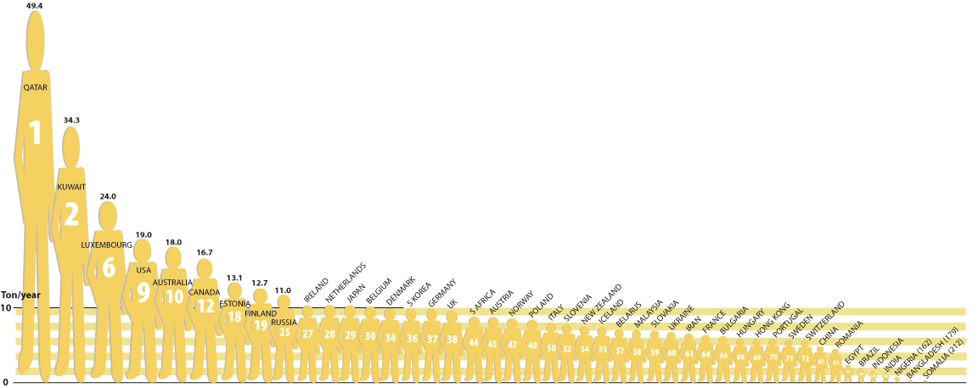
Figure 1. [CLICK TO ENLARGE] Emissions of CO2 per capita (tons/year) for selected nations. Source: cdiac.ornl.gov/trends/emis/top2006.cap, recalculated from ton C to CO2.
Any fair attribution of the problem must also consider emissions per capita. Total greenhouse gas emissions are not available for non-Annex I countries, but there is data for CO2 emissions. Figure 1 shows per capita emissions for a selection of countries. The countries that have the lowest emissions are, apart from Afghanistan, poor and often war-torn African nations: Eritrea, Mozambique, Congo (formerly Zaire) etc, all of which have emissions of 0.1 ton per person or less. Some of these countries have a large population, but their contribution to the climate problem is nevertheless almost negligible. The five highest emitters are all oil nations, as are several others near the top of the table.
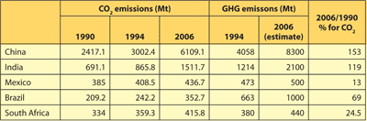
Table 2. Emissions of greenhouse gases by selected emerging economies. Sources: CO2 from 1990, 1994 and 2006 from cdiac.ornl.gov/trends/emis/meth_reg.html, (recalculated from C to CO2). 1994 GHG from unfccc.int/ghg_data/ghg_data_unfccc /ghg_profiles/items/4626.php, estimate under the assumption that the GHG/CO2 relation is the same as in 1994.
There is broad correlation between the prosperity of a nation and the size of its emissions, but the link is not clear-cut. South Africa is not richer than Switzerland, but it has higher per capita emissions. Estonia is not richer than Sweden, but has carbon dioxide emissions that are twice as high.
Most striking, however, are the high emission figures for the USA, Canada and Australia – around ten times as high as countries such as India and Indonesia.
China is by far the largest country in the world by population, and also comes top for carbon dioxide emissions. On a per capita basis, emissions are on a par with Switzerland or Sweden. By comparison, per capita emissions from the USA are four times higher. China has also stated that a significant share of its growing emissions are “implicit”, since it exports products with a high carbon footprint to other countries, rather than consuming them domestically. These implicit emissions will not be quantified here, but clearly also have implications for the USA.
Summaries that cover the period to 2006 or 2007 do not however say much about the future, and may not even give a clear picture of the situation today. A number of climate policy decisions have been or soon will be agreed, and new climate targets have been adopted in many countries. In 2007 the EU was still in the trial period for emissions trading, and an over-generous allocation of emissions then led to a market collapse. Despite a very serious economic crisis this situation has not been repeated.
The combination of more restrictive allocations, a recession and many different national measures means that the EU may be able to meet its commitments for the entire period 2008–2012 at the domestic level.
An estimate by the European Environment Agency1 suggests that emissions by the EU15 in 2008 could reach a total of minus 6.2 per cent. There is obviously no data for 2009, but it is clear that reductions will continue into this year.
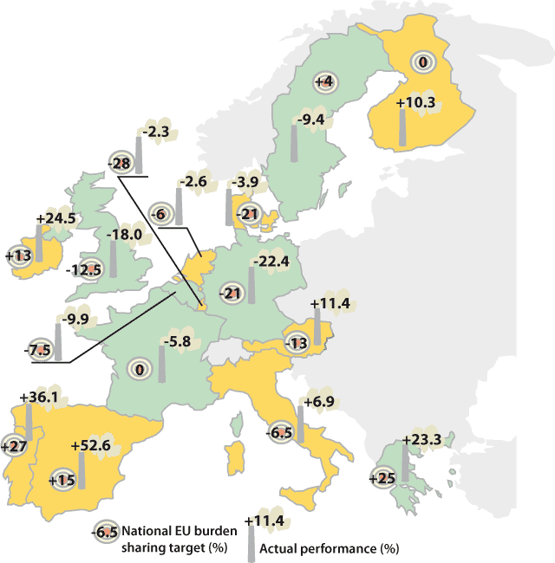
Figure 2. [ CLICK TO ENLARGE.]
Targets and performance for greenhouse gas emissions in EU15. Performance is based on 2007 emissions.
As can be seen in figure 2, there are big differences in performance between the EU countries. The differences remain, even after burden sharing is taken into account. While Belgium, France, Germany, Greece, Sweden and the UK all had lower emissions in 2007 than they undertook to meet by 2008–2012, the majority of countries were far from their targets. The worst was Spain, which was almost 40 per cent too high, and Austria at almost 30 per cent too high. The best was Sweden, with emissions that were over 13 per cent lower than allocated under burden sharing.
The gap between the best and worst countries can to some extent be ascribed to unpredictable developments, such as the German reunification, ageing power generation plants in the UK, which sparked the country’s “dash for gas”, and an unreasonably low burden allocation for Sweden. However, there is no doubt that some of the difference is also due to stronger (or earlier) implementation of climate policy in the better countries compared with the others.
The difference becomes even more striking when comparing the USA, Australia and Canada with the EU15, or with Germany and the UK. The wide gap in emissions that existed in 1990 not only remains but has grown rapidly. Although European climate policy can be accused of being weak, late in coming and inconsistent, it has nevertheless led to declining emissions. In the USA, Australia and Canada, coal and oil interests have been able to steer policy until very recently.
Despite the big changes that are now taking place in all these countries, as well as Japan, many years have been lost since the UN first drew serious attention to the climate issue in 1987.
Fortunately these years have not been entirely wasted. Some of these countries, including some of the worst performers, have taken steps that do not show in emission statistics, but are still significant. This is true of Denmark, which for a number of years was responsible for a large share of global investment in wind power, until the baton was passed first to Germany, then Spain, the USA and a long list of other countries. Wind power is now not only a theoretical alternative but also accounts for a significant proportion of new power generation around the world. Solar water heating is an important energy source in China and is now being exported on a large scale.
Photovoltaic solar electricity still lags a number of years behind wind power, but is also on the way to becoming an important energy source. Japan was the leading manufacturer for many years, but China is now establishing its place. For a number of years the main market was in Germany, but Spain has now taken over and in 2008 accounted for almost half the new capacity in the world2 in a year when the global market for solar panels more than doubled in size. Spain’s leading role in renewables is largely due to a shift in policy following a change of government in 2003.
The growth and availability of fossil-free alternatives for producing electricity and hot water in multi-gigawatt capacities is largely due to climate-related political initiatives. Politics plays a role. Even a relatively small country can sometimes change the global playing field when it comes to climate policy.
Fredrik Lundberg
Proposal to designate an emission control area for nitrogen oxides, sulphur oxides and particulate matter submitted by the United States and Canada. IMO MEPC 59/6/5, 2 April 2009.
1) www.eea.europa.eu/highlights/new-estimates-confirm- the-declining-trend-in-eu-greenhouse-gas-emissions
2) www.epia.org/press-releases.html March 24, 2009.

