GIS Development, Jan 2009

Of the people? By the people? For the people?


Sumit Sen
Head, Training & Research, GIS Development
sumit.sen@GISdevelopment.net
The policy term for geographic information was coined very early in the life cycle of the technology, even when the technology was not mainstream and many IT streams like security and Web technologies were nascent.
Today, as most regions in the globe have highly evolved policy and legal frameworks for other sections of IT, policies about geospatial information, in a wider perspective still remains an unaccomplished objective. Great challenges exist in creating policies that govern, promote and ensure the effective use of geospatial information. Central to these challenges is the fundamental question as to who are these policies aimed at. While speaking about the national level, are these policies for the people of a nation? In an increasingly democratic world (taking cognizance of the various flavours of democracy), one needs to comprehend the underlying radical distinction between (1) information privy to a select few who "govern" the "governed" or (2) information based on democratic principles with citizens or people at the centre. Some initial thoughts on this debate come from the very theory of governance. Prof Rahul De, IIM Bangalore, has studied the often quoted 'Bhoomi' land records project and he explains that a Structuration Theory and an Actor Network theory are central to our understanding of e-governance. While the Structuration Theory assumes the effects of IT mediated interaction in the structure of organisations, De also mentions the actors in the Actor Network comprised of designers, builders and maintainers of IT artifacts. It is stated that actors in a network enroll other actors to influence the interests
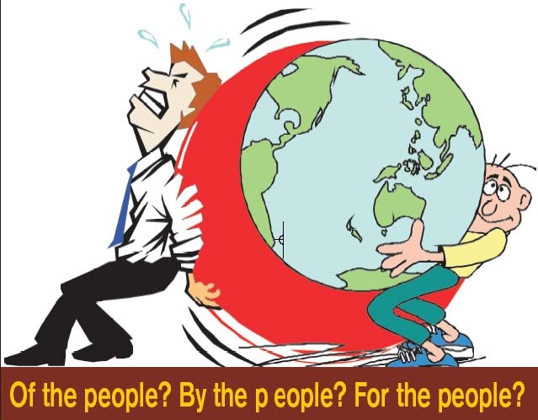
The debate about best policies for GI has been a long and unfinished one hed one. This article goes into the fundamental issues and provides two complementary perspectives. Firstly, policies about GI in a nation are con are controlled by the very nature of its governance. Secondly, the use of GI in the policy making of the nation signifies the role of GI and GI and hence has implications about policies for GI themselves.
of others, which is an indirect way of expressing one's power in a network. The apparent contradiction of the two approaches is evident from the presumed effect of greater participation on the "power" of a person in question. The resultant notion is stronger than the aspect of merely a digital divide and tends to offer a thesis and an antithesis as to the reasons why GI policies have never been open and democratic in the first place. The distinction is also very strong when one notes that most of the utilisation of GI technologies that have been reported are rather on a 'governance' perspective rather than 'e-democracy'. Donald Lenihan (2002) elaborates that the notion of 'e-governance' ranges from 'putting services online' to 'renewing democracies'. Thus GIS has mostly catered to the former.
In order to distinguish between the basic tasks of governments, i.e., policy and service delivery, it is important to take cognizance of the role GI presently has in each of the two. In an increasingly (liberal) democratic society, service delivery and questions related to "who and how" of delivery of the service are losing their centre stage to the policy counterparts. While the overall GI policies of a country are tied to the archetype of e-governance that it opts for, it seems clear that the restrictive GI policies come from the topic of "delivery of services" and rooted in Structuration Theory. Such a myopic view of the policy domain is in conflict with the principles of democracy. In democratically mature nations, especially regions sans colonial legacies, 'e-governance' assumes 'people focus' and have adopted an underlying message of 'GI of the people, by the people, for the people' In contrast, most nations with debatable democratic backgrounds or with
GI For Policy Making
Geospatial Information (GI) is critical to most public policy decisions, though it is merely a technology tool which works only in tandem with institutional and legal factors as discussed by Yola Georgiadou. Based on the understanding of spatio-temporal dynamics of human settlements in the context of spatio-temporal nature of the physical environment they settle in, the optimal use of GI is critical in the adoption of appropriate policies. It is important to note GI is utilised not only to analyse the spatial relationship of various factors, from depravity and poverty to hazard assessment. It is used, in a larger extent, to get a grasp of future trends, create worst case scenarios, debate the alternatives in policy and in some sense, mitigate risks of policy initiatives.
There are two major fallacies that come across easily in the context of the use of GI for policy making. The first being more ubiquitous; that GI is a rather modern tool for policy planners and that spatial analysis is an idea that has been in existence only of late. On the contrary, advances in mathematics, at least in most advances in mathematics as reported in the history of most civilisations owe their foundations to the notions of distance and its role in policy making. It is perhaps with the advent of time, these techniques have become hackneyed. But there are several advantages that GI systems provide. Dyke (et al) pointed out in 1996, the use of such systems is pivotal in the scalability of policy analysis based on its computational prowess. Some of the areas where GI for policy making has been explored include.
- Environmental policies
- Health and social welfare
- Poverty & deprivation
Urban (infrastructure) planning and policy Irrespective of the domain, it is relevant to note the credibility that is given to GI in rendering what can be considered as evidence support for policy making. Wise and Craglia write in the book, "… the general relation among policy, evidence and GIS, which cannot ignore these apparently arcane remarks about representation. The commonsensical and unexceptionable suggestion that policy should be based on evidence occludes all manner of questions about the relation among narrative, evidence and representation.
Because the overall pattern of urban development or the extent of urban intensification cannot be perceived in a glance, its appreciation is not a matter of individual development, GIS use must recogniae and reproduce (though possibly in a modified form) widely shared, credible communicable representation which fit the categories used within policy discourse."
Representation within GIS is a matter of contention and hence has bigger implications for policy makers. Policy makers could constitute the global community dealing with climate change or a local community near the Aquila river, in Mexico . In both cases, GIS based representation has helped to provide a story which has resonated and has lead to important results. Gilberto Camara, in his keynote address at GI Science in 2006 stated that results from INPE efforts of earth observation, in the form of GI of earth observation have paid richly towards policies on Amazon forests.
Scalability of GI and GI systems comes handy in every aspect of policy making, as can be seen in the above examples. However, they also bring us to the second fallacy that GI tools are more appropriate, for planning in underdeveloped nations and deprived regions. Often academic work and news articles highlight the work done in Africa and Asia, which utilises GI in a significant way. However, such tools are used in policies, beyond the notion of governments and corporate policies related to marketing, recruitment, sales and distribution are also being based on GI.
But the role of GIS in urban governance, especially in the participatory mode is endemic. Rina Ghose's work in Milwaukee, Wisconsin, is exemplary, demonstrating the conventional utility of GIS in planning and service delivery tasks of local governments, besides promoting a top down rational planning model. She writes that "scalar politics is strongly constructed by various actors as a strategy to control material resources and urban space through citizen participation and GIS use in inner city neighborhoods". She explains the theoretical frameworks that illustrate hidden complexities in Participatory GIS and states that political processes play a significant role, in which entrenched hierarchies and power relations significantly affect citizen participation and technology/data sharing.
The participatory and empowering role of GI in communication and enabling ordinary citizens to exercise this legitimate power in a modern democratic world is the most important policy aspect of GI. It remains to be seen if policies that govern the use of GI in today's world take cognizance of this outlook.
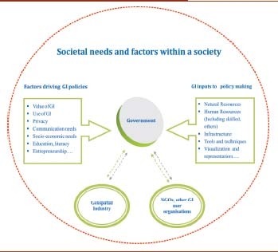
strong colonial legacies, have evolved an alternate viewpoint that persists with an "empowered few" governing the state. The less empowered group includes common citizens and nongovernment enterprises. The list of countries that continue to ban the commercial use of GPS bear testimony to this observation, viz, North Korea, Syria and Egypt.
In effect, the creation, updation, access, use or further augmentation of geospatial information of a democratic nation should not lie with a select few, even under the pretext of national security. The recent incident in Mumbai terrorist strikes highlights the lack of preparedness to use geospatial information on the part of ordinary citizens to escape harm as much as security agencies which tried to confront the perpetrators of violence.
It is futile to expect governments to let the race for information, especially in such scenarios, be fought in such a disadvantaged circumstance for its citizens. This was also strongly evident at the recent NSDI meet at New Delhi, where the science and technology minister, expounded the need to make geospatial information available to ordinary citizens of the nation, possibly free of charge. The perspective of a politician, a key stakeholder in democracy, to empower citizens did not resonate with that of the bureaucracy. There are further instances of such discrepancies in the UK. The pricing of geospatial data provided by Ordnance Survey and
its classification as public goods has been in continuous debate. Roger Longhorn and Michael Blakemore (2003) had discussed the charge levied on Public Sector Information(PSI) as double taxation and the apparent dilemma over decreasing government funding on agencies.
The core issue that is in focus, as elaborated by the Guardian's Technology Supplement, in March 2008, was that even while Ordnance Survey and the UK Hydrographic office are designated as trading funds, substantial parts of their finance (upto 50%) come from the public sector. The recent debate about Ordnance Survey employing political lobbying on the issue of free data which in turn was brought into light by www.freeourdata.org.ukand highlights the "information power struggle"
Moving beyond the policy debate, it is non-trivial to note that policies and their implementation go hand in hand. In spite of having a national map policy in India, its value to society has been largely inconsequential. Contrastingly, without a comprehensive policy document, Singapore has emerged as a model implementer of SDIs, with its implementation of LandNet and INLIS. Other countries in this region like Malaysia, Indonesia or Thailand, lie at different levels of preparedness. GI policies were taken up as a core topic of GI Science studies as early as 1970s but have not matured enough to formulate a theory that can approximately account for its value to society. The failure should be seen in the context of the constricted view of the role of 'people' in the scheme of things. There are fallacies about the use of GI in its service to societies, especially in its role in policy making. The two aspects of GI policies and the effects of GI policy on society are mutually complementary. They are necessary to explain the force that drives Web 2.0 interfaces for GI such as Google maps, Microsoft Virtual Earth or map annotations.
It is true that specialist groups like decision makers in town planning, ministry of the interior and defence forces require access to GI to serve a nation, irrespective of the progress in the citizen's right to information. As Dirk Kempthrone, US Secretary of the Interior, puts it at the ESRI user's conference in August 2008, "My vision for the future is that with the click of a mouse, decisionmakers and land managers… will have access to maps that Lewis and Clark could never have imagined." Lastly, it is not possible to ignore the issues of privacy while we discuss GI policies, especially with the emergence of new paradigms of communication on the Web and ubiquitous and pervasive sensors.
However, the implication of privacy issues on GI policies within a society has a lot to do with the deep societal values that it nurtures. Just as some countries are more tolerant to individual freedom of expression, we are bound to have different policies (with or without smooth boundaries for such policies) in relation to privacy. Some of the work in this area, points to the need for explicit specification of the overall objectives of the privacy policy. Harlan Onsrud, University of Maine, believes that privacy protection is better achieved through moral standards than legal ones which need explicit specification and would not achieve universality in any case.
The progress on this debate has been rather slow. For example the FGDC in the US identifies a policy on access and privacy but does not provide details of various levels of "information privacy" violations and technical steps to enforce them. The true reflection of a nation can be seen in the principles it follows and GI policies serve as great examples. It needs to be seen in totality and also questions need to be answered about the need to work on the issues of map literacy and cultural aspects inhibiting the scientific use of GI. While democracies enable such possibilities, the reverse process, of enabling democracy through such societal changes is equally effective.

