State of the Climate
Global Analysis
April 2010

National Oceanic and Atmospheric Administration

National Climatic Data Center

Contents of this Section:
- Introduction
- Temperatures
- Precipitation
- Sea Ice
- NH Snow Cover
- Troposphere
- Stratosphere
- References

Global Highlights
- The combined global land and ocean average surface temperature for April 2010 was the warmest on record at 14.5°C (58.1°F), which is 0.76°C (1.37°F) above the 20th century average of 13.7°C (56.7°F). This was also the 34th consecutive April with global land and ocean temperatures above the 20th century average.
- The worldwide ocean surface temperature was 0.57°C (1.03°F) above the 20th century average of 16.0°C (60.9°F) and the warmest April on record. The warmth was most pronounced in the equatorial portions of the major oceans, especially the Atlantic.
- The April worldwide land surface temperature was 1.29°C (2.32°F) above the 20th century average of 8.1°C (46.5 °F)—the third warmest on record.
- For the year-to-date, the global combined land and ocean surface temperature of 13.3°C (56.0°F) was the warmest January-April period. This value is 0.69°C (1.24°F) above the 20th century average.

Please Note: The data presented in this report are preliminary. Ranks and anomalies may change as more complete data are received and processed. Effective with the July 2009 State of the Climate Report, NCDC transitioned to the new version (version 3b) of the extended reconstructed sea surface temperature (ERSST) dataset. ERSST.v3b is an improved extended SST reconstruction over version 2. For more information about the differences between ERSST.v3b and ERSST.v2 and to access the most current data, please visit NCDC's Global Surface Temperature Anomalies page.

Introduction
Temperature anomalies for April 2010 are shown on the dot maps below. The dot map on the left provides a spatial representation of anomalies calculated from the Global Historical Climatology Network (GHCN) dataset of land surface stations using a 1961–1990 base period. The dot map on the right is a product of a merged land surface and sea surface temperature (SST) anomaly analysis developed by Smith et al. (2008). For the merged land surface and SST analysis, temperature anomalies with respect to the 1971–2000 average for land and ocean are analyzed separately and then merged to form the global analysis. For more information, please visit NCDC's Global Surface Temperature Anomalies page.

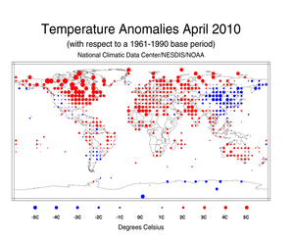
April Land Surface Temperature
Anomalies in degrees Celsius
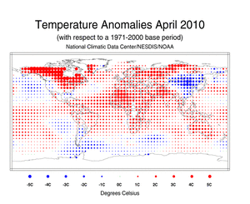
April Blended Land and Sea Surface
Temperature Anomalies in degrees Celsius

April 2010
April 2010 was characterized by very warm conditions across much of the world. Warmer-than-average conditions during April 2010 were present across much of the world's land areas. The warmest anomalies occurred in southern Asia, northern Africa, the north central and northeastern U.S., Canada, Europe, and parts of northern Russia. Although much of the world's land area was engulfed by warmer-than-average temperatures, cooler-than-average conditions prevailed across Argentina, Mongolia, eastern and southern Russia, and most of China. The worldwide land temperatures for April 2010 ranked as the third warmest—behind 2007 (warmest) and 2000 (second warmest)—on record, 1.29°C (2.32°F) above the 20th century average. Sea surface temperatures (SST) during April 2010 were the warmest on record, with an anomaly of 0.57°C (1.03°F) above the 20th century average. Warmer-than-average conditions enveloped much of the world's oceans, with cooler-than-average conditions across the higher-latitude southern oceans and parts of the northern Pacific Ocean. Although temperatures across the equatorial Pacific Ocean remained above 0.5°C (0.9°F), El Niño weakened during April 2010 as temperature anomalies cooled across the region. According to NOAA's Climate Prediction Center (CPC), a transition to El Niño Southern Oscillation (ENSO) neutral conditions is expected by June 2010 and to continue into the Northern Hemisphere summer 2010. Overall, the combined global land and ocean surface temperature anomaly for April 2010 was the warmest April on record since records began in 1880. The previous record was set in 1998. The combined global land and ocean temperature anomaly was 0.76°C (1.37°F) above the 20th century average.

Did you know?
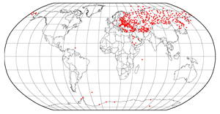
NOAA's National Climatic Data Center (NCDC) is the world's largest active archive of weather data. It houses data archives dating back to 1880 from all over the world. Each month, countries from all over the world send their land-based meteorological surface observations, meaning temperature and precipitation measurements, to NCDC to be added to the global record. This information is sent through the World Meteorological Organization's (WMO) Global Telecommunication System (GTS)—a coordinated system for the rapid collection, exchange and distribution of observation data from more than 200 countries around the world. The data are sent in a format called "CLIMAT messages", which are a summary of monthly weather data for a specific station. The CLIMAT message contains information of average pressure at station level, average air temperature, maximum air temperature, minimum air temperature, average vapor pressure, total precipitation, and total sunshine for a particular month. These messages are typically sent to NCDC by the 8th of every month. NCDC uses the data to produce numerous climate publications, such as the monthly global state of the climate report. The red dots on the loop above show how a typical month's worth of data arrives at NCDC, in a day-by-day, country-by-country fashion. Please refer to the WMO for detailed information about CLIMAT messages or the GTS.
The April 2010 average temperature for the Northern Hemisphere as a whole (land and ocean surface combined) was 0.89°C (1.60°F) above the 20th century average—the warmest April on record. The previous record was set in 2007. The Northern Hemisphere ocean temperature during April 2010 ranked as the warmest on record, with an anomaly of 0.56°C (1.01°F) above the 20th century average—the previous record was set in 2005. However, the Northern Hemisphere land was the third warmest on record, behind 2000 (warmest) and 2007 (second warmest). This value was 1.42°C (2.56°F) above the 20th century average.
According to the German Meteorological Service (Deutscher Wetterdienst), the mean temperature for Germany as a whole was 8.7°C (47.7°F), which is 1.3°C (2.3°F) above the 1961–1990 base period. April 2010 was the 27th warmest April since 1901.
The April 2010 average temperature across China was 9.1°C (48.4°F), which is 1.2°C (2.2°F) below the 1971–2000 average—resulting in the coolest April since 1961, according to the Beijing Climate Center (BCC). The provinces of Liaoning, Jilin, and Shandong had their coolest April on record, while Hebei, Anhui, and Jiangsu experienced their second coolest April since records began in 1951.
According to the India Meteorological Department (IMD), warm conditions were present in Delhi, India during April 2010. It was reported that Delhi had its warmest maximum temperature during the month when temperatures soared to 43.7°C (110.7°F) on 18 April 2010. This was the highest maximum temperature since April 1958 [43.7°C (110.7°F)]. The all-time record for the city is 45.6°C (114.1°F) set on 29 April 1941.
The average temperature for the Southern Hemisphere as a whole (land and ocean surface combined) was 0.64°C (1.15°F) above the 20th century average—the second warmest April on record, behind 1998. The Southern Hemisphere ocean temperature during April 2010 also represented the second warmest on record, with an anomaly of 0.60°C (1.08°F) above the 20th century average. The April 2010 Southern Hemisphere land temperature was 0.94°C (1.69°F) above the 20th century average—the fourth warmest April on record.
According to Australia's Bureau of Meteorology (BoM), April 2010 was warmer than normal over most of the country. For Australia as a whole, minimum temperatures were 1.68°C (3.02°F) above average, resulting in the second highest minimum temperatures, behind 2005. Regionally, Western Australia had its second highest minimum temperatures, while South Australia, Tasmania, and Victoria had their third highest on record. Meanwhile, maximum temperatures were 0.93°C (1.67°F) above normal for the continent—the tenth highest maximum temperature on record. It was reported that Western Australia had its fifth highest maximum temperature on record.
Australia's BoM also reported that Victoria and Tasmania experienced their warmest 12-month period (May 2009–April 2010) since national records began. Separately, all twelve months were warmer than average for both states, with October being the exception for the state of Tasmania. These warm conditions contributed to the anomalously warm temperature during May 2009–April 2010. The mean temperature during May 2009–April 2010 for the state of Victoria was 15.36°C (59.65°F), which is 4.36°C (7.85°F) above average. The previous record of 15.25°C (59.45°F) was set on February 2007–January 2008. Similarly, Tasmania had a mean temperature of 11.43°C (52.57°F) during May 2009-April 2010, which is 2.43°C (4.37°F) above average—exceeding the previous record of 11.34°C (52.41°F) set on May 1998-April 1999. It was reported that the mean temperature during May 2009–April 2010 for Australia as a whole was 22.69°C (72.84°F), which is 0.88° (1.58°F) above average—resulting in the third warmest 12-month period on record, behind 1997–1998 and 2005–2006.
Of note, Melbourne's (Victoria's capital) daily maximum temperature exceeded 20°C (68°F) for 123 consecutive days (8 December 2009 - 10 April 2010), surpassing the previous record of 78 consecutive days above 20°C (68°F).

Year-to-date (January–April)
The 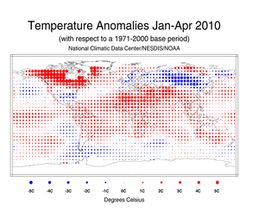January–April 2010 map of temperature anomalies shows that for the first four months of the year anomalous warm temperatures were present over much of the world, with the exception of cooler-than-average conditions across the higher-latitude southern oceans, the northern Pacific Ocean, along the western South American coast, Mongolia, northern China, northern Australia, the south central and southeastern U.S., northern Mexico, and most of Europe and Russia. The combined global land and ocean surface temperature for January–April period was the warmest January-April period on record. This value is 0.69°C (1.24°F) above the 20th century average. Separately, the worldwide land surface temperature ranked as the third warmest on record, behind 2007 (warmest) and 2002 (second warmest), while the worldwide ocean surface temperature ranked as the second warmest January–April on record—behind 1998.
[ top ]

The average position of the upper-level ridges of high pressure and troughs of low pressure (depicted by positive and negative 500-millibar height anomalies on the 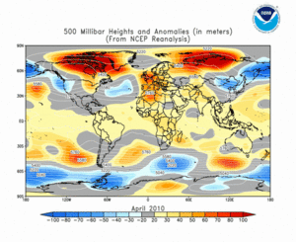April 2010 map, respectively) are generally reflected by areas of positive and negative temperature anomalies at the surface, respectively. For other Global products, please see the Climate Monitoring Global Products page.
Images of sea surface temperature conditions are available for all weeks during 2009 from the weekly SST page.

Temperature Rankings and Graphics
Current Month | Year-to-date
April | Anomaly | Rank  (out of 131 years) | Warmest/Next Warmest  Year on Record
Global
Land | +1.29°C (+2.32°F) | 3rd warmest | 2007 (+1.42°C/2.56°F)
Ocean | +0.57°C (+1.03°F) | 1st warmest | 1998 (+0.56°C/1.01°F)
Land and Ocean | +0.76°C (+1.37°F) | 1st warmest | 1998 (+0.71°C/1.28°F)
Northern Hemisphere
Land | +1.42°C (+2.56°F) | 3rd warmest | 2000 (+1.67°C/3.01°F)
Ocean | +0.56°C (+1.01°F) | 1st warmest | 2005 (+0.51°C/0.92°F)
Land and Ocean | +0.89°C (+1.60°F) | 1st warmest | 2007 (+0.85°C/1.53°F)
Southern Hemisphere
Land | +0.94°C (+1.69°F) | 4th warmest | 2005 (+1.05°C/1.89°F)
Ocean | +0.60°C (+1.08°F) | 2nd warmest | 1998 (+0.62°C/1.12°F)
Land and Ocean | +0.64°C (+1.15°F) | 2nd warmest | 1998 (+0.65°C/1.17°F)
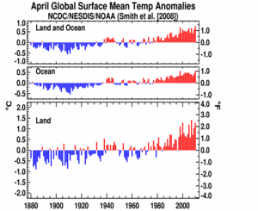
April Global Land and Ocean plot
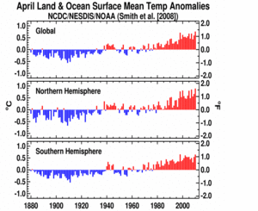
April Global Hemisphere plot
January - April | Anomaly | Rank  (out of 131 years) | Warmest/Next Warmest  Year on Record
Global
Land | +1.07°C (+1.93°F) | 3rd warmest | 2007 (+1.32°C/2.38°F)
Ocean | +0.55°C (+0.99°F) | 2nd warmest | 1998 (+0.56°C/1.01°F)
Land and Ocean | +0.69°C (+1.24°F) | 1st warmest | 2002 (+0.68°C/1.22°F)
Northern Hemisphere
Land | +1.13°C (+2.03°F) | 5th warmest | 2007 (+1.53°C/2.75°F)
Ocean | +0.53°C (+0.95°F) | 1st warmest | 1998 (+0.52°C/0.94°F)
Land and Ocean | +0.76°C (+1.37°F) | 3rd warmest | 2007 (+0.86°C/1.55°F)
Southern Hemisphere
Land | +0.92°C (+1.66°F) | 1st warmest | 2005 (+0.87°C/1.57°F)
Ocean | +0.58°C (+1.04°F) | 2nd warmest | 1998 (+0.60°C/1.08°F)
Land and Ocean | +0.62°C (+1.12°F) | 2nd warmest | 1998 (+0.63°C/1.13°F)
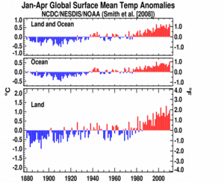
January-April Global Land and Ocean plot
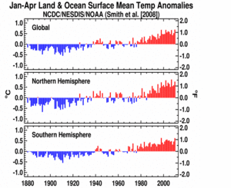
January-April Global Hemisphere plot
The most current data may be accessed via the Global Surface Temperature Anomalies page.
[ top ]

Precipitation
The maps below represent anomaly values based on the GHCN dataset of land surface stations using a base period of 1961-1990. Precipitation anomalies on a month-to-month basis are often highly variable across the globe and even within regions. The areas with the wettest anomalies during April 2010 included eastern Brazil, northern South America, and parts of eastern Asia. The driest anomalies were present across the Hawaiian Islands, the southern Pacific Islands, southern South America, and parts of central Europe.
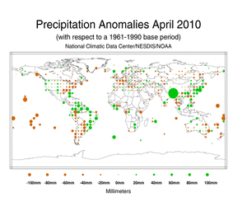
April 2010 Precipitation Anomalies in Millimeters
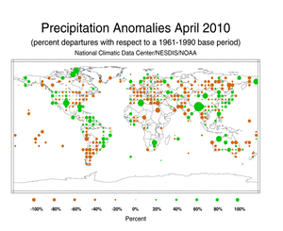
April 2010 Precipitation Percent Departures
According to Beijing Climate Center (BCC), the monthly averaged precipitation in China was 56.1 mm (2.2 inches) during April 2010, which is 12.3 mm (0.5 inch) above the 1971–2000 average—resulting in the wettest April since 1974. On a provincial level, Tibet had its wettest April since national records began in 1951. It was reported that beneficial rains since March 2010 alleviated drought in Southwest China. Heavy rain fell during April 10th–14th and April 19th–22nd, triggering deadly floods that caused 15 fatalities (Source: BCC).
Australia as a whole experienced above average rainfall during April 2010 (34 percent above average), the 17th wettest April on record. Averaged nationally during the wet season (October–April), October 2009–April 2010 ranked as the 16th wettest such period since national records began in 1900. Regionally, the Northern Territory had its fifth-wettest October–April (34 percent above average) and New South Wales had its seventh-wettest period on record (15 percent above average).
According to the German Meteorological Service (Deutscher Wetterdienst), the monthly averaged precipitation in Germany was 20.7 mm (0.8 inch)—which is 37.5 mm (1.5 inches) below average. This value ranks as the second driest April since 1901, behind 2007.
According to Mexico's National Water Commission (CONAGUA), Mexico, as a whole, had its third wettest April in 69 years.
In New Zealand, soil moisture deficits continued to affect many areas of the North Island. According to New Zealand's National Institute of Water and Atmospheric Research (NIWA), April 2010 was a very dry month for much of the North Island and northern South Island. Although much needed precipitation fell over drought-stricken areas, it wasn't enough to alleviate drought. In April 2010, drought was declared in Auckland, Waikato, Bay of Plenty, South Taranaki, South Canterbury, and Otago. In contrast, Fiordland, south Westland, and parts of Southland were extremely wet during April 2010 as more than double the average precipitation fell in the region.
Additional details on flooding and drought can also be found on the April 2010 Global Hazards page.
[ top ]

NH Snow Cover Extent
Analyses of NOAA data were provided by the Global Snow Laboratory, Rutgers University. Period of record is 1967-2010.
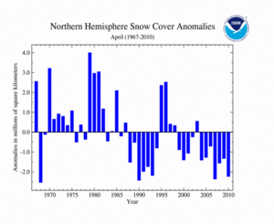
April's Northern Hemisphere
Snow Cover Extent plot
April 2010 snow cover extent was below the 1967–2010 average for the Northern Hemisphere. This marked the hemisphere's seventh consecutive April with below-average snow cover extent. Warmer-than-average conditions over North America, Europe, and parts of Russia contributed to the region's fourth-lowest April snow cover extent during the period. The average Northern Hemisphere April snow cover extent for the 1967–2010 period of record is 30.5 million square kilometers.
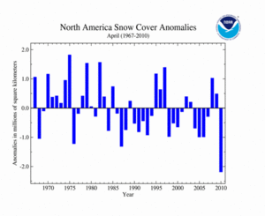
April's North America
Snow Cover Extent plot
Across North America, snow cover for April 2010 was 2.2 million square kilometers below average—the lowest April snow cover extent since satellite records began in 1967 and the largest negative anomaly to occur in the 521 months that satellite measurements are available. Unlike the previous two years, which had above-average snow cover extent, April 2010 low extent could be attributed to the anomalous warm conditions that engulfed much of North America during the month, resulting in low snowfall amounts and rapid snow melt. The average North American April snow cover extent is 13.2 million square kilometers for the 1967-2010 period of record. For information on the U.S. April 2010 snow events, please visit the April 2010 Snow and Ice report.
According to Environment Canada, Ontario's snow season (September 2009–April 2010) was extraordinarily below average, setting many record low seasonal snowfall amounts. Toronto had a total of 46.2 cm (18.2 inches) of snowfall, surpassing the previous seasonal record low of 44.8 cm (17.6 inches) set in 1952–1953. Toronto's average seasonal snowfall is 133.1 cm (52.4 inches). Meanwhile, Kapuskasing had a total of 164.2 cm (64.7 inches) of total seasonal snowfall, resulting in a new record low snowfall amount. This value is 138.9 cm (54.7 inches) below the average of 303.1 cm (119.3 inches). The previous record was set in 1941–1942 when a total of 206.2 cm (81.2 inches) of snow fell during the snow season.
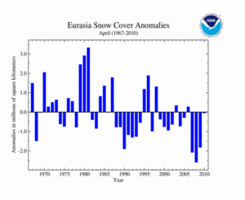
April's Eurasia
Snow Cover Extent plot
Although much of Eurasia had warmer-than-average conditions, the average Eurasian snow cover extent during April 2010 was near average. In contrast to the past three years, which ranked among the top four lowest April snow cover extents, April 2010 was near average—ranking as the 24th lowest (21st largest) April snow cover extent. The 44-year average Eurasian snow cover extent in April is 17.3 million square kilometers for the period of record. According to Beijing Climate Center, parts of northern China had snow storms and frost during April 2010, resulting in more than six billion yuan (878 million U.S. dollars) in direct economic losses.
[ top ]

Sea Ice Extent
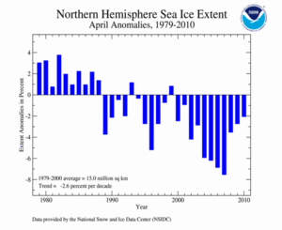
April's Northern Hemisphere
Sea Ice Extent plot
Arctic sea ice reached its maximum extent of the year on March 31st, 2010—the latest date for the maximum sea ice extent since records began in 1979—and has begun its annual retreat, typically reaching a minimum in September. Arctic sea ice extent during April 2010 was marked by a typical decline, contributing to a near-average monthly extent. According to the National Snow and Ice Data Center (NSIDC), the April 2010 Northern Hemisphere sea ice extent was 14.7 million square kilometers (2.1 percent or 310,000 square kilometers below the 1971–2000 average), resulting in the 15th lowest (18th largest) April Arctic sea ice extent and the largest April Arctic sea ice extent since 2001, when sea ice extent was just 0.9 percent below the 1971–2000 average. It was reported that slightly above-average sea ice extent was present in the Bering Sea and Sea of Okhotsk, while below-average conditions remained in the Barents Sea north of Scandinavia and in Baffin Bay. April Arctic sea ice extent has decreased at an average rate of 2.6 percent per decade since 1979.
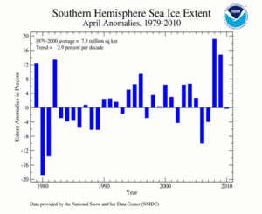
April's Southern Hemisphere
Sea Ice Extent plot
April 2010 Southern Hemisphere sea ice extent was 0.3 percent below the 1979–2000 average. Unlike the two previous years, which are the largest and second largest sea ice extent years, April 2010 was near average. Southern Hemisphere sea ice extent for April has increased at an average rate of 2.9 percent per decade.
For further information on the Northern and Southern Hemisphere snow and ice conditions, please visit the NSIDC News page, provided by NOAA's National Snow and Ice Data Center (NSIDC).
[ top ]

Troposphere
Temperatures above the Earth's surface are measured within the lower troposphere, middle troposphere, and stratosphere using in-situ balloon-borne instruments (radiosondes) and polar-orbiting satellites (NOAA's TIROS-N). The radiosonde and satellite records have been adjusted to remove time-dependent biases (artificialities caused by changes in radiosonde instruments and measurement practices as well as changes in satellite instruments and orbital features through time). Global averages from radiosonde data are available from 1958 to present, while satellite measurements date back to 1979.

Lower Troposphere
Current Month | Year-to-date
These temperatures are for the lowest 8 km (5 miles) of the atmosphere. Information on the University of Alabama in Huntsville (UAH) and Remote Sensing Systems (RSS) sources of troposphere data is available.
April | Anomaly | Rank  (out of 32 years) | Warmest (or Next Warmest)  Year on Record | Trend
UAH low-trop | +0.50°C/+0.90°F | 2nd warmest | 1998 (+0.76°C/+1.37°F) | +0.14°C/decade
RSS low-trop | +0.55°C/+0.98°F | 2nd warmest | 1998 (+0.86°C/+1.54°F) | +0.18°C/decade

January-  April | Anomaly | Rank  (out of 32 years) | Warmest (or Next Warmest)  Year on Record | Trend
UAH low-trop | +0.60°C/+1.08°F | 2nd warmest | 1998 (+0.66°C/+1.19°F) | +0.14°C/decade
RSS low-trop | +0.61°C/+1.10°F | 2nd warmest | 1998 (+0.68°C/+1.22°F) | +0.17°C/decade

Mid-troposphere
Current Month | Year-to-date
These temperatures are for the atmospheric layer centered in the mid-troposphere (approximately 3–10 km [2–6 miles] above the Earth's surface), which also includes a portion of the lower stratosphere. (The Microwave Sounding Unit [MSU] channel used to measure mid-tropospheric temperatures receives about 25 percent of its signal above 10 km [6 miles].) Because the stratosphere has cooled due to increasing greenhouse gases in the troposphere and losses of ozone in the stratosphere, the stratospheric contribution to the tropospheric average, as measured from satellites, may create an artificial component of cooling to the mid-troposphere temperatures. The University of Washington (UW) versions of the UAH and RSS analyses attempt to remove the stratospheric influence from the mid-troposphere measurements, and as a result the UW versions tend to have a larger warming trend than either the UAH or RSS versions. For additional information, please see NCDC's Microwave Sounding Unit page.
The radiosonde data used in this global analysis were developed using the Lanzante, Klein, Seidel (2003) ("LKS") bias-adjusted dataset and the First Difference Method (Free et al. 2004) (RATPAC). Additional details are available. Satellite data have been adjusted by the Global Hydrology and Climate Center at the University of Alabama in Huntsville (UAH). An independent analysis is also performed by Remote Sensing Systems (RSS) and a third analysis has been performed by Dr. Qiang Fu of the University of Washington (UW) (Fu et al. 2004) to remove the influence of the stratosphere on the mid-troposphere value. Global averages from radiosonde data are available from 1958 to present, while satellite measurements began in 1979.
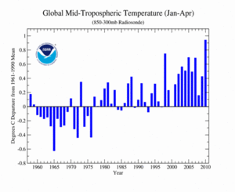
RATPAC January-April plot
Radiosonde measurements indicate that, for the January-April year-to-date period, temperatures in the mid-troposphere were 0.94°C (1.70°F) above average, resulting in the warmest January–April (out of 53 years) since global radiosonde measurements began in 1958. Meanwhile, satellite analyses of the January–April year-to-date period for the middle troposphere were second warmest in the 32-year satellite record, behind 1998.
The global mid-troposphere temperatures were above average during April 2010. As shown in the table below, satellite measurements for April 2010 ranked second or third warmest on record, depending on the source.
April | Anomaly | Rank  (out of 32 years) | Warmest (or Next Warmest)  Year on Record | Trend
UAH mid-trop | +0.34°C/+0.61°F | 2nd warmest | 1998 (+0.71°C/+1.28°F) | +0.04°C/decade
RSS mid-trop | +0.39°C/+0.70°F | 2nd warmest | 1998 (+0.75°C/+1.35°F) | +0.09°C/decade
UW-UAH mid-trop | +0.44°C/+0.78°F | 2nd warmest | 1998 (+0.85°C/+1.53°F) | +0.10°C/decade
UW-RSS mid-trop | +0.48°C/+0.87°F | 3rd warmest | 1998 (+0.88°C/+1.58°F) | +0.14°C/decade

January–  April | Anomaly | Rank  (out of 32 years) | Warmest (or Next Warmest)  Year on Record | Trend
UAH mid-trop | +0.40°C/+0.72°F | 2nd warmest | 1998 (+0.60°C/+1.08°F) | +0.04°C/decade
RSS mid-trop | +0.48°C/+0.86°F | 2nd warmest | 1998 (+0.63°C/+1.13°F) | +0.10°C/decade
UW-UAH mid-trop | +0.51°C/+0.92°F | 2nd warmest | 1998 (+0.73°C/+1.31°F) | +0.10°C/decade
UW-RSS mid-trop | +0.60°C/+1.08°F | 2nd warmest | 1998 (+0.75°C/+1.35°F) | +0.16°C/decade
RATPAC* | +0.94°C/+1.70°F | warmest | 1998 (+0.75°C/+1.35°F) | +0.15°C/decade
*RATPAC's rank is based on records that began in 1958 (53 years).
[ top ]

Stratosphere
Current Month
The table below summarizes stratospheric conditions for April 2010. On average, the stratosphere is located approximately 16–23 km (10–14 miles) above the Earth's surface. Over the last decade, stratospheric temperatures have been below average in part due to the depletion of ozone. The large positive anomaly in 1982 was caused by the volcanic eruption of El Chichon in Mexico, and the sharp jump in temperature in 1991 was a result of the eruption of Mt. Pinatubo in the Philippines. In both cases the temperatures returned to pre-eruption levels within two years.
April | Anomaly | Rank  (out of 32 years) | Coolest Year on Record
UAH stratosphere | -0.35°C (-0.63°F) | 13th coolest | 1999 (-0.69°C/-1.24°F)
RSS stratosphere | -0.35°C (-0.63°F) | 11th coolest | 1999 (-0.65°C/-1.16°F)
[ top ]

For additional details on precipitation and temperatures in April, see the Global Hazards page.

References
Christy, John R., R.W. Spencer, and W.D. Braswell, 2000: MSU tropospheric Temperatures: Dataset Construction and Radiosonde Comparisons. J. of Atmos. and Oceanic Technology, 17, 1153-1170.
Free, M., D.J. Seidel, J.K. Angell, J. Lanzante, I. Durre and T.C. Peterson (2005) Radiosonde Atmospheric Temperature Products for Assessing Climate (RATPAC): A new dataset of large-area anomaly time series, J. Geophys. Res., 10.1029/2005JD006169.
Free, M., J.K. Angell, I. Durre, J. Lanzante, T.C. Peterson and D.J. Seidel(2004), Using first differences to reduce inhomogeneity in radiosonde temperature datasets, J. Climate, 21, 4171-4179.
Fu, Q., C.M. Johanson, S.G. Warren, and D.J. Seidel, 2004: Contribution of stratospheric cooling to satellite-inferred tropospheric temperature trends. Nature, 429, 55-58.
Lanzante, J.R., S.A. Klein, and D.J. Seidel (2003a), Temporal homogenization of monthly radiosonde temperature data. Part I: Methodology, J. Climate, 16, 224-240.
Lanzante, J.R., S.A. Klein, and D.J. Seidel (2003b), Temporal homogenization of monthly radiosonde temperature data. Part II: trends, sensitivities, and MSU comparison, J. Climate, 16, 241 262.
Mears, CA, FJ Wentz, 2009, Construction of the RSS V3.2 lower tropospheric dataset from the MSU and AMSU microwave sounders. Journal of Atmospheric and Oceanic Technology, 26, 1493-1509.
Mears, CA, FJ Wentz, 2009, Construction of the Remote Sensing Systems V3.2 atmopsheric temperature records from the MSU and AMSU microwave sounders. Journal of Atmospheric and Oceanic Technology, 26, 1040-1056.
Mears, Carl A., M.C. Schabel, F.J. Wentz, 2003: A Reanalysis of the MSU Channel 2 tropospheric Temperature Record. J. Clim, 16, 3650-3664.
Peterson, T.C. and R.S. Vose, 1997: An Overview of the Global Historical Climatology Network Database. Bull. Amer. Meteorol. Soc., 78, 2837-2849.
Quayle, R.G., T.C. Peterson, A.N. Basist, and C. S. Godfrey, 1999: An operational near-real-time global temperature index. Geophys. Res. Lett., 26, 333-335.
Smith, T.M., and R.W. Reynolds (2005), A global merged land air and sea surface temperature reconstruction based on historical observations (1880-1997), J. Clim., 18, 2021-2036.
[ top ]

Questions?
For questions on technical or scientific content of this report, please contact:
Ahira Sánchez-Lugo:
Ahira.Sanchez-Lugo@noaa.gov
For general climate monitoring questions, please contact:
CMB.Contact@noaa.gov
For climate data orders, please contact the National Climatic Data Center's Climate Services and Monitoring Division:
NCDC.Orders@noaa.gov

