Acid News, March 2009
Stricter emission limits for trucks and buses
The European Parliament agreed in December to a proposal that emissions of nitrogen oxides from new heavy duty vehicles shall be cut by 80 per cent and those of particulate matter by 66 per cent, as compared to existing standards.
Air quality is still a significant problem throughout the European Union, especially in urban areas and in densely populated regions. Heavy-duty vehicles are responsible for a significant proportion of total pollutant emissions from transport and make a major contribution to air quality problems in European cities.
Emission standards for heavy vehicles have been gradually tightened over time (see figure). In December 2007, the European Commission proposed tougher limits on harmful exhaust emissions from heavy vehicles, including ozone precursors such as nitrogen oxides (NO_{x}) and hydrocarbons (HC) as well as fine particles (PM).
During autumn 2008, representatives of Parliament and Council agreed on a compromise package, which was adopted by the European Parliament on 16 December 2008. The new regulation, the so-called Euro VI emission standards, lays down harmonized technical standards for heavy vehicles (trucks, lorries and buses) over 2,610 kg, which all new vehicles will have to comply with, thus replacing the Euro V limits which have applied since October 2008.
Euro VI will apply from 31 December 2012 for new type approvals and one year later for all new vehicles. To become final, the Euro VI package still has to be adopted by the Member States in Council, which is expected to occur shortly.
The compromise backs the Commission’s proposed lower limit values for emissions of several pollutants (see table). The limit value for NO_{x} will be 400 milligrams per kilowatt hour (mg/kWh), which is 80 per cent less than the current Euro V limit value, and the PM limit will be 10 mg/kWh – a 66-per-cent reduction compared with the Euro V limit.
According to the Commission, the new limits will be a step forward towards global harmonisation since the limit values are similar to those of the United States. The US 2010 standards for heavy-duty vehicles are set at 0.2 grams NO_{x} per gram per brake horsepower/hour (g/bhp-hr) and 0.01 PM g/bhp-hr, which equals approximately 270 mg NO_{x}/kWh and 13 mg PM/kWh.
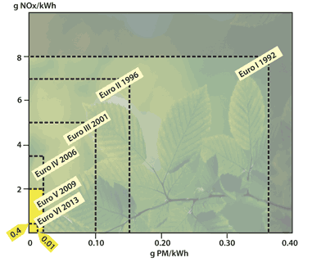
Figure: Development of European emission limits for NO_{x} and PM from heavy duty vehicles.
Jos Dings, director of Transport and Environment (T&E) said: “The EU has done the right thing by getting these long-overdue standards agreed. But lorries have a nasty habit of looking a lot cleaner in the testing laboratory than in the real world. Close monitoring will be needed to ensure nitrogen oxides and other harmful emissions really go down.”
Emission limits in the proposal are still based on old European test cycle procedures (ESC and ETC). Once correlation factors are developed – but no later than 1 April 2010 – the limits will be replaced with limit values for the new world harmonized testing, the WHSC and WHTC, World Harmonized Stationary Cycle and Transient Cycle, respectively.
Also by 1 April 2010, a particle number standard is to be defined. The particle number limits are “likely to reflect the highest levels of performance currently obtained with particle filters according to the best available technology”, says the proposal.
The currently agreed text does not introduce a separate emission limit for the nitrogen dioxide (NO₂) component of NO_{x}. The Commission is asked to, if appropriate, propose such limit at a later, unspecified date.
Finally, the compromise also follows the Commission’s proposal to enable Member States to provide for financial incentives to speed up the placing on the market of vehicles meeting the new requirements.
“t is important to encourage the early enforcement of the Euro VI standards to improve urban air quality and the quality of life of European citizens,” said Dragomira Raeva, policy officer at the European Environmental Bureau (EEB). “Member states should back the early introduction of Euro VI vehicles and retrofitting of existing vehicles with financial incentives.”
Christer Ågren
For more information, see:
http://ec.uuropa.eu/enterprise/automotive/

