

Third International Conference on Small Island Developing States Opens in Samoa ma, Sep 1, 2014
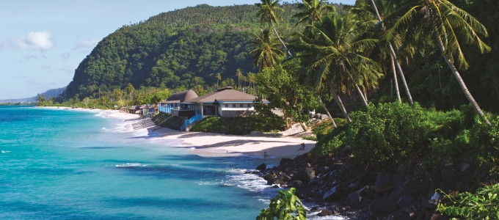
Coastal shoreline;Samoa/Photo credit:David Kirkland.
Apia, Samoa, 1 September 2014 - Heads of State, policymakers, business leaders and representatives from civil society have gathered in Apia, Samoa, to pledge their support for small island developing states by forging partnerships that will help these nations to overcome a unique set of environmental and economic challenges.
UN Under-Secretary-General and UNEP Executive Director Achim Steiner and other high-level UNEP officials are in attendance during the Third International Conference on Small Island Developing States - the largest international meeting ever held in the Pacific - which will run from 1-4 September and seeks to focus the world's attention on issues faced by small island nations, such as climate change, environmental degradation and access to energy.
"We are here to seek a renewed commitment to small island developing states by focusing on practical actions and durable partnerships," said UN Secretary-General Ban Ki-moon as he addressed the conference.
With the slogan, "Island Voices, Global Choices," and with 'genuine and durable partnerships' as its theme, the conference has brought to the spotlight the need to strengthen island initiatives that can help address pressing global issues.
In his remarks, Mr. Ban stressed that the world needs to listen to small islands as their issues have global consequences.
"I see small island developing states as a magnifying glass," Mr. Ban said. "When we look through [their] lens, we see the vulnerabilities we all face. And by addressing the issues facing small island developing states we are developing the tools we need to promote sustainable development across the entire world."
Ahead of the conference, participants held a Major Groups and Other Stakeholders Forum and Youth Forum, both of which will help to inform the conference plenary sessions and other events; a Renewable Energy Forum; and a Private Sector Forum, during which UNEP spotlighted the importance and necessity of a transition towards a blue-green economy, with particular attention to technology access, adequate investment, access to markets and support to Small and Medium-Sized Enterprises, providing jobs and making best use of the digital economy.
The conference itself will be made up of plenary sessions, side events and six Multi-stakeholder Partnership Dialogues on the following topics: sustainable economic development; climate change and disaster risk management; social development in SIDS, health and non-communicable diseases, youth and women; sustainable energy; oceans, seas and biodiversity; and water and sanitation, food security and waste management. UNEP will take part in each Multi-stakeholder Partnership Dialogue, presenting partnerships and other initiatives that can help to support SIDS.
UNEP leadership at the highest levels will take part in a number of these dialogues, as well as important side events. On Monday, Achim Steiner will join the Prime Minister of Samoa H.E. Tuilaepa Sailele Malielegaoi, Secretary-General of the conference Wu Hongbo, Administrator of UNDP Helen Clark and other Heads of UN Agencies at a High-level side event of the UN System Chief Executives Board for Coordination (CEB). The CEB issued a joint statement to the Third International Conference on Small Island Developing States in May.
UNEP will host three side events alongside its partner, the Secretariat of the Pacific Regional Environment Programme (SPREP), and other countries and agencies. The first, entitled "Challenges and Opportunities for Sustainable Consumption and Production in SIDS," will include high-level panel discussions to explore the added value of sustainable consumption and production (SCP) for SIDS. In addition, an "SCP for SIDS Initiative", within the 10 Year Framework of Programmes on Sustainable Consumption and Production will be announced.
A second side event is entitled, "SIDS Pathway to an Inclusive Green Economy and Poverty Reduction." Organized by UNEP in conjunction with UN-ESCAP, the Pacific Islands Development Forum and SPREP, it will focus the unique case of SIDS transitioning to an inclusive Green Economy, highlighting specific initiatives and experiences of SIDS and formulating concrete recommendations for action.
The third UNEP side event, "The Last Straw: Preventing our Oceans from Becoming Dumps," will spotlight examples of low-cost and innovative multi-stakeholder solutions to prevent and manage marine litter. It will present good practices and initiatives of SIDS to reduce and manage the influx of waste into the marine environment from land and sea-based sources.
An important UNEP contribution to the Third International Conference on Small Island Developing States has been its support - alongside the host country, the UN Department of Economic and Social Affairs and other partners - for the sustainability of the conference itself.
Earlier this year, UNEP, SPREP, the Samoan Ministry of Natural Resources and Environment, Ministry of Health and the Samoa Tourism Authority embarked on a campaign to help address the forecast increase in waste generated during the SIDS Conference, with an eye to improve waste management practices beyond the conference. The campaign included a waste audit that took place in March, of over 40 Samoan hotels and other accommodation venues and ports of entry to be used during the Conference.
As part of the ongoing SIDS waste management preparations, a technical workshop was also held to help hotel managers and other stakeholders to improve waste management practices and methods for the SIDS conference.
In addition, a guidance note for conference participants was compiled with the help of UNEP and other partners. Among other things, participants were urged to identify and minimize greenhouse gas (GHG) emissions relating to their travel and participation in the meeting activities, by using public transport; using re-usable and recycled products, and offsetting GHG emissions by financing local sustainable development projects.
For more information, please contact:
UNEP Newsdesk, Nairobi, Kenya: unepnewsdesk@unep.org

