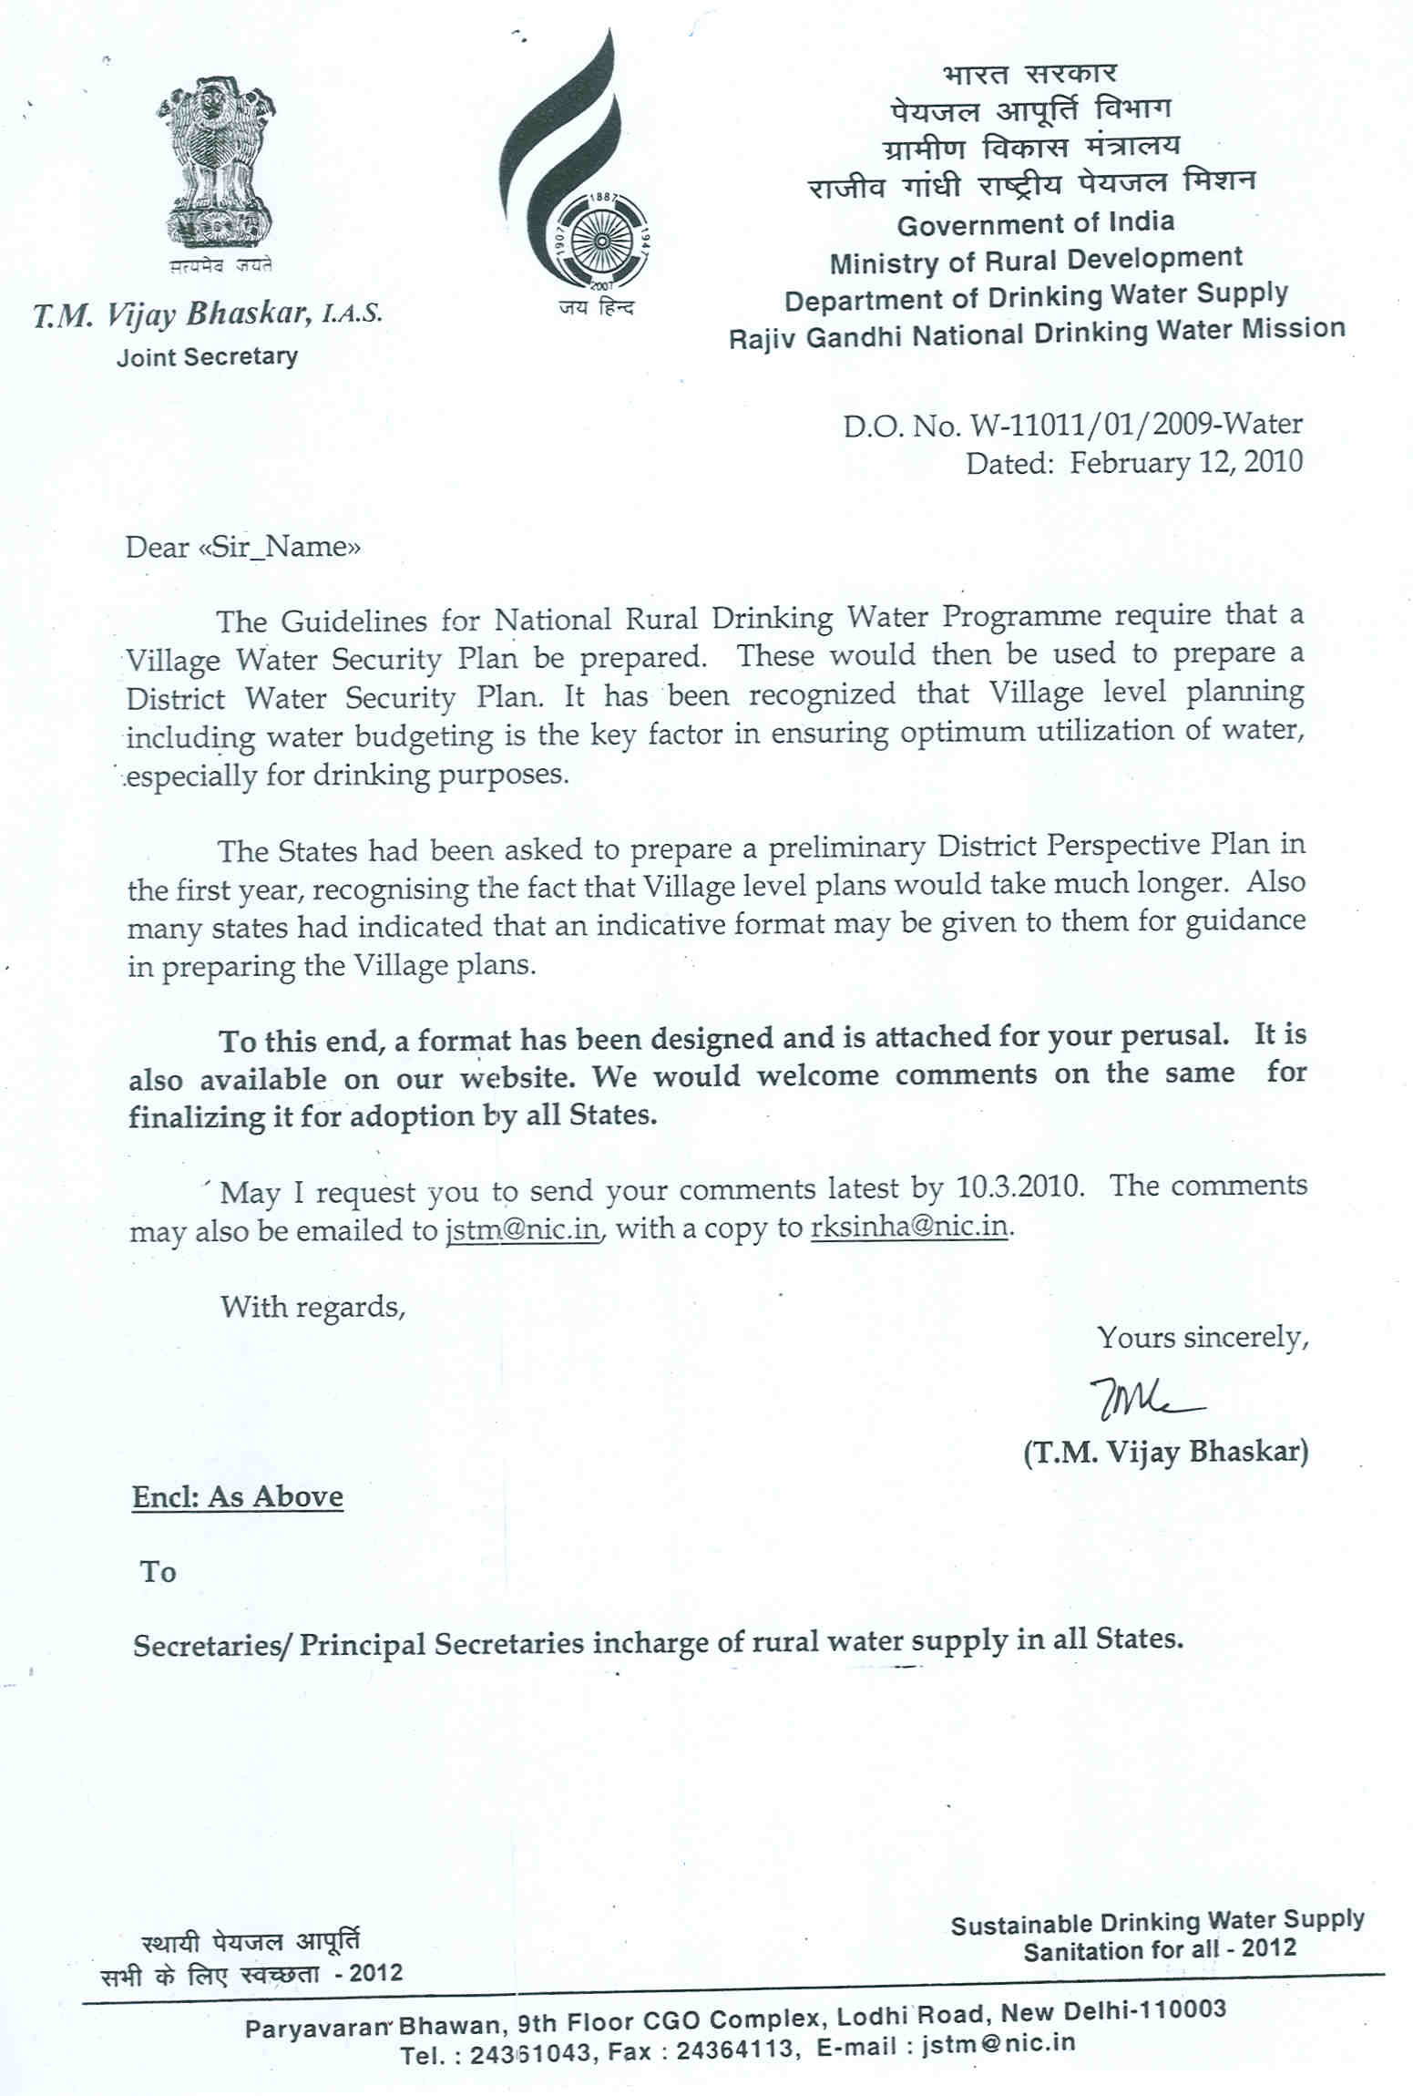

Draft
Guideline for the preparation of Village Water Security Plan (VWSP)

Background

The revised National Rural Drinking Water Programme (NRDWP) Guidelines 2009-2012 issued by Rajiv Gandhi National Drinking Water Mission, Department of Drinking Water Supply has shift the focus from ‘source development and installation of water supply system for providing drinking water supply to rural household’ to focus on development of ‘village security plan’ which also includes village safety plan before taking up planning & installation of water supply system to ensure provision of safe and adequate water supply to each rural household at a convenient location on a sustainability basis. Basically it envisage provision of drinking water as a part of the overall water resource management.

2. Logistic support required

To enable the GP, VWSC and the field staff of State Rural Water Supply Department to prepare VWSP as per the new guideline and as per the existing institutional set up in the States the following logistic support is required and it is pre requisite:

- In the new guideline (NRDWP) under frame work for Water Quality Monitoring & Surveillance (Annexure IV para 4) it is indicated under sub heading Proposed Strategy “For data collection at the household level and at the habitation level one person preferably women from VWSC elected at Gram Sabha under the control of GP and paid appropriately on job basis for the specified activities. The person selected will be designated as “JAL SURAKSHAK”
- Water Quality Testing Laboratory with computer facilities (fund for the same is provided in the new guideline) are to be in place at the Sub-Division (PHED) Level for testing of all the village-wise drinking water sources (chemical and bacteriological) from where the house holds collects water.
- GPS instruments (provision made under MIS guideline) are to be procured for identification of water resources in the villages for development of village water resource maps.
- Collect water and sanitation related data from NRHM so that sanitary inspection can be carried out for identification of source of contamination and take remedial measures
- Household and village data analysed at the sub-division level along with data from NRHM will enable VWSC under the technical guidance of field staff of PHED to prepare village water security plan which includes water safety plan which is basically identification for source of contamination (hazard analysis) and take corrective measures for the existing water supply system both for safe and unsafe sources including government and or private water supply system
- Based on the village water security plan the action plan for planning of new/augmentation of the water supply scheme is to be prepared in consultation with all stake holders

3. Inter Departmental Convergence:
- To prepare village security plan in put from State Ground Water Board, State Water Resource Department, Irrigation Department and PHED will be required as these departments have to a great extent micro-level data. CGWB and NRSA data are broad based, block based and require highly specialized hydrologist to understand and analyze the existing information and maps for preparation of village level water security plan.
- To understand the water and sanitation disease burden and remedial measures, coordination with village level functionaries of the National Rural Health Mission is highly essential.
- Community should develop its own village water security plan taking into consideration the present water availability, reliability and its different usage and equity based on experience and wisdom. At the village level the water resource (both surface and ground water) can not be measured it can be only be judged in term of adequate and inadequate.
- Women generally manage domestic water, and an essential ingredient of community participation is to improve women’s involvement in the democratic decision-making process. Since women are the principal beneficiaries of this programme and are pivot around which sustainability is evolved, it is of critical importance that women are involved at all the stages of planning, implementation and management of rural water supply schemes. Women’s associations could provide a strong framework for community participation. Prominent women from the habitation should be represented in the Village Water & Sanitation Committees/ Pani Samitis.
- For the community to function as an organization it is important to make Village Water and Sanitation Committee (whose members should be elected in Gram Sabha) fully functional and effective VWSC should be made a standing committee of the Gram Panchayat.

4. Suggestive formats

4.1. General Profile
1 | Name of Village and census code
2 | Gram panchayat
3 | Block
4 | District
5 | Number of Households in village
6 | Population of village in numbers (as per Census 2001)  Total-  Male  Female
7 | Present Population of village in numbers ( Present as per survey)  Total-  Male  Female

4.2 Habitation Details
S. No. | Name of Habitation | Code of habitation | Population (in No.) | No. of public and private drinking water sources | No of Households
 |  |  |  |  | SC | ST | Other | Total
(1) | (2) | (3) | (4) | (6) | (10) | (11) | (12) | (13)
1)
2)
3)
4)
5)
6)

4.3 Household water security plan survey format
Proforma No.
Block: |  |  | Gram Panchayat:
Village: |  |  | Habitation:
A | Basic information
1 | Household Head Name:
2 | Category (BPL , APL )  Belonging to SC/ ST/ Minorities/ Others
3 | No. of family members | Male | Female | Children | Total
B | Source
4 | Source of water (Public, Private)
5 | If Public, Type of source
5 | Spot sources | PWSS | Street Standpost (PWS)(6) | House Connection | Others (Specify)
6 | If Private type of source |  | Spot source | Pond/spring etc | Others
7 | Distance between house and water source point in meters ( below 100 m - 200m - 1, 200 - 500 m-2, above 500 m - 3)
8 | Whether water availability is round the year (Yes - 1, No- 2)
9 | If No, how many month it remains dry / inadequate
C | Water requirement for HH consumption
10 | Use / consumption of water for family in L | Drinking/ cooking | Washing utensils | other purposes | Total
11 | Type of source used |  | Drinking/ cooking | Washing utensils | other purposes
12 | Whether the available water is adequate for drinking/cooking purpose ( Yes , No)  What is the amount of water charge you pay ?  How much time does it take to fetch water for domestic needs (to reach the source and fetch water from there in minutes) 0-30 min, 30 min – 1 hr, 1 hr and above  Who fetches water normally in your house  Men Women Male children Female children Helper/ others
13 | If no, additional demand in litres |  | Drinking / Cooking | other purposes | total
D | Household water management
14 | Is there any storage facility available in the Household (Yes, No)
15 | If yes, HH level storage capacity available in L |  | Drinking/cooking | other purposes | total
16 | Do the HH have any water filter (yes, No)
17 | If yes, it regularly used? (yes, No)
18 | If no, would like to have filter? (yes, No)
19 | Do they have any idea about where the filter could be procured? (yes, No)
20 | Is they have any idea about the relationship between water quality and disease burden (yes, No)
E | Knowledge, Attitude and Practise (KAP
21 | Water container is covered with lid (Yes, No)  How long did you experience water?
22 | Whether HH use long handle ladder / tap to take out water? (Yes, No)
23 | Whether the container is kept at higher plat form ( Yes, No)
F | Operation and Maintenance
24 | Whether aware about Village Water and Sanitation Committee in the village? (yes - 1, No - 2)
25 | Is the family willing to pay community contribution towards O&M (Yes - 1, No- 2)
G | Water quality & Disease burden
26 | whether aware about the quality of the water source (Yes - 1, No- 2)
27 | Incidence of Diseases burden during last 3 months, no. of cases | Diarrohea | Cholera | Malaria | Jaundice
28 | Approximate medical expenditure incurred during last 3 months in Rs ( below one hundred - 1, above one hundred – 2)
H | Additional information
29 | Whether HH is having toilet facility (Yes-1, No-2)  How many members use toilet regularly?  How many members defecate in the open regularly.?
30 | Whether family members use soap for hand washing before eating? (Ys -1, No-2)
31 | Whether family members use soap for hand washing after defecation? (Ys -1, No-2)
32 | Whether HH is having RWH structures?(Yes-1, No-2)
33 | Type of House (Pukka - 1, Kuchha – 2)
34 | Willingness to construct RWH in house (Yes - 1, No -2)
35 | Approximate roof area of house ( in sq.m)
I | Data management
36 | Sanitary survey score |  |  | Public | Private
37 | GPS Survey | Water Source |  | Water Source
37 | GPS Survey | Latitude | Longitude | Latitude | Longitude
 | Laboratory report
38 | Water Source ID | Source(Public/Private) | Type (system) | Year of installation
38 | Water Source ID | Depth (M) | SWL (M) | Discharge level | Sample collection date
39 | Testing date and results (only sample quality category indicated) | pH | Total Hardness (mg/L) | Arsenic (mg/L)
39 |  | Iron (mg/L) | Total Coliform (MPN/100ml) | Faecal Coliform (MPN/100ml)
J | Water budget
40 | Requirement/ Demand of water for the family |  | Drinking/cooking | other purposes | Total
41 | Current availability of water |  | Drinking/cooking | other purposes | Total
42 | Balance requirement |  | Drinking/cooking | other purposes | Total

4.4 Institutional detail:

S. No. | Name of Habitation | Schools | College | Anganwadi Centres | Hospitals | Others
1.
2.
3.
4.
5.
6.
 | Total

4.5 Institutional water security plan format

Institutional water security plan - Baseline Survey
Proforma No.
Block: |  |  | Gram Panchayat:
Village: |  |  | Habitation:
A | Basic information
1 | Institution Name:
2 | If school, No. of Students, if other institution means the total no. of persons | Boys | Girls | Total
B | Source
3 | Source of water (Hand pump, PWS)
4 | Location of Hand pump ( Inside the campus, Outside the campus)
5 | PWS connection ( Inside school, Outside school)
6 | Supply of water through PWS ( Continuous, intermittent)
7 | Distance between Institution and water source point in meters
8 | Whether water availability is round the year (Yes, No)
9 | If No, how many months it remains dry
C | Water requirement for Institution consumption
10 | Use / consumption of water in L |  | Drinking/cooking | other purposes | Total
11 | Type of source used (specify) |  |  | Drinking/cooking | Other purposes
12 | Whether the available water is adequate ( Yes, No)
13 | If no, additional demand in Ltrs |  | Drinking/cooking | other purposes | total
D | Institutional water management
14 | Is there any storage facility available in the Institution (Yes, No)
15 | If yes, storage capacity available in Ltrs |  | Drinking/cooking | other purposes | total
16 | Do the institution have any water filter (yes, no)
17 | If yes, is it regularly used? (yes, no)
18 | If no, would they like to have filter? (yes, no)
19 | Do they have any idea about where the filter could be procured? (yes, no)
20 | Do they have any idea about the relationship between water quality and disease burden (yes, no)
H | Additional information
21 | Whether institution is having toilet facility (Yes, No)  a) Whether toilet has adequate facility for cleaning and handwashing?  b) Who cleans the toilet?
22 | Whether institution is having RWH structures?(Yes, No)
23 | Type of building (Pukka, Kuchha)
24 | Willingness to construct RWH (Yes, No)
25 | Approximate roof area of school building
E | Data management
26 | Sanitary survey score
27 | GPS Survey | Water Source 1 |  | Water Source 2
27 | GPS Survey | Latitude | Longitude | Latitude | Longitude
G | Laboratory report
28 | Water Source ID | Type | Year of sinking | Depth (M) | SWL (M)
28 | Water Source ID | Discharge level | Sample collection date
29 | Testing date (quality data as per requirement) | pH | Total Hardness (mg/L) | Arsenic (mg/L)
29 | Testing date (quality data as per requirement) | Iron (mg/L) | Total Coliform (MPN/100ml) | Fecal Coliform (MPN/100ml)
I | Water budget
30 | Requirement of water for the institution
31 | Supply of water for the institution
32 | Balance requirement

5 Water demand assessment

Analysis of water requirement

At the end of household survey, all the facilitators will sit together and compile the information. The village action plan template will be completed, and the following analysis will be conducted.

The purpose of this analysis is to identify the present situation, water demand and gap, with probable solutions as offered by the community. This information will be put on a large chart by the facilitators and will be shared with the community during the village meeting.
- Total nos of households in the village as per survey
- Total nos of households which does not have water security for drinking water in a complete year. What is the gap (For how much days the water security is not available)? And if the house is pucca, the area of roof in sq.m.
- Total nos of households which do not have water security for other purposes in a complete year. What is the gap (For how much days the water security is not available)? And if the house is pucca, the area of roof in sq.m.
- Total nos of water sources available in the village as per survey
- Nos of functional water sources available in the village as per survey
- Nos of non functional water sources available in the village as per survey
- How many of the non functional sources can be repaired/rejuvenated
- Nos of water sources affected by water quality parameter and can not be used for drinking purposes. Individual water source to be analysed for which parameter or parameters of water quality is not under permissible limits. Can this water source can be treated for water quality problem?
- Nos of traditional water sources available in the village , how many out of them are presently being used , for which purpose, how many out of them are not being used but can be revived, what is the quality of water?
- Total nos of institutions and their individual pucca area
- Water availability for complete village combined (Drinking and other purposes) as well as separate(Drinking and other purposes) and gap as per the survey
- Probable solutions as offered by the community in percentage and as per priority.
- Topography sheet showing habitations, streets, position of existing water sources and slopes is to be prepared. This will help community in selecting options.

6 Summary of Household water security plan survey

S.No | Habitation name | Total No. of HH | No. of HH having adequate safe water supply | Additional quantity of water safe required in L

7. Village profile based on HH survey

Village Profile based on HH survey
S.No | Particulars |  |  |  | Details
A | Primary Information
1 | No. of habitations
2 | Population
3 | No. of families
B | Source | Whether working or defunct |  | Whether water supplied  a) regularly  b)Sometimes  c) Irregular | Whether all communities use this source | Quality of water  Good/ Bad
4 | No. of public water sources
4 | a) Hand pump
4 | b) Dugwell
4 | c) Street Stand Post(PWS)
4 | d) HH Connection
4 | e) Others
5 | No. of private water sources
5 | a) Hand pump
5 | b) Dugwell
5 | c) Others
6 | No. of families using public water sources
7 | No. of families using private water sources
8 | No. of families using PWS
9 | No. of families using protected water supply ( Sanitary risk <5)
10 | a) No. of water sources accessible within 100 m - 200m
10 | b) No. of water sources accessible within 200 m - 500m
10 | c) No. of water sources accessible > 500 m
11 | Frequency of water collection per day ( No. of families)
11 | a) one time
11 | b) Two times
11 | c) more than 2 times
12 | No. of families taking time to collect water of
12 | a) less than 30 min
12 | b) above 30 min  c) below 60 min  d) above 60 min
13 | No. of families getting water round the year
C | Water requirement for HH consumption
14 | Consumption of water in L
14 | a) Drinking/ cooking
14 | b) Washing Utensils
14 | c) Other purposes
14 | d) Total
15 | a) No. of families using HP as drinking water source
15 | b) No. of families using DW as drinking water source
15 | Whether water available throughout the year  a) Parts of the year  b) Stops during summer
15 | Common causes cited for water supply disruption:  a) Poor maintenance b) Power cut  c) Source has gone dry  d) Reduced water availability  e) Lack of staff f) contaminated water  g) Irregular staff h) population increase  i) financial crunch
15 | c) No. of families using PWS as drinking water source
15 | d) No. of families using pond water as drinking water
15 | e) No. of families using HP as drinking water source
15 | f) No. of families using DW as drinking water source
15 | g) No. of families using PWS as drinking water source
15 | h) No. of families using pond water as drinking water
16 | No. of families getting adequate water
17 | Additional demand L
17 | a) Drinking / cooking
17 | b) Other purposes
D | Household water management
18 | No. of families have HH level water storage facility
19 | No. of families aware about the place of filter availability
20 | No. of families having HH water filter
21 | No. of families regularly using filter
22 | No. of families interested to procure filter
23 | No. of families aware about linkages between water quality and health
E | KAP
24 | No. of households covering container with lid
25 | No. of HH using long handle ladder/ tap to take out water
26 | No. of HH keeping water at higher platform
F | O&M
27 | No. of families willing to contribute money for O&M
G | Water Quality and disease burden
28 | No. of families aware about the quality of water
29 | Incidence of water borne diseases in last three months ( No. of cases)
29 | a) Diarrohea
29 | b) Chlolera
29 | c) Malaria
29 | d) Jaundice
30 | Medical expenses ( No. of families) for last three months
30 | a) Below Rs. 100
30 | b) Above Rs. 100
31 | No. of HH having toilets
32 | a)No. of families washing hand with soap before taking food
 | b)No. of families washing hand with soap after defecation
33 | No. of HH having RWH
34 | No. of families willing to construct RWH
35 | Water Quality and sanitary score ( as per lab report)
35 | a) Safe
35 | b)Unsafe
35 | i) Chemical
35 | ii) bacteriological
35 | c)Sanitary risk score > 5
36 | Water budget
36 | a)Requirement of water for the village
36 | b)Availability of water for the village
36 | c)Balance requirement of water for the village

8. Community consultation for selection of technical options

After the completion of HH survey and compilation of data, all the facilitators, surveyor, technical resource person and PHED engineer will organise a village meeting with community members, PRI members and members of VWSC/Gram. The participatory techniques will be used by the facilitators for developing the village action plan for water security.

The purpose of the village meeting is as follows:
- Problem identification
- Problem analysis
- Planning for solutions
- Selecting options
- Finalizing options with capital and operation and maintenance cost at individual level as well as at community level
- Finalizing the mechanism for management of water supply schemes inside the village and developing the rules for sharing O&M cost and regulation for equitable water distribution
- Finalising source sustainability measures recharge structures – RWSS
- Finalise capacity building plan for GP/ VWSC members, pump operators, mechanics, watermen, engineers
- Agreement on Village Action Plan and approved by GP/VWSC/ community

The following steps are to be followed for development of the village action plan:

- Here the technical person/PHED person will explain the technical and financial details for the all the options selected by community ( Source sustainability, feasibility of the option, geological conditions, capital cost, O&M cost per year, rain water harvesting capital cost and management cost at institutional and individual level, differential use of water etc) to the community and VWSC. Based on the discussions the VWSC will finalise the options at village and individual level. The finalised options will be listed out by the facilitator with details of capital, management and O&M cost and their mechanism. The rules for equitable distribution of water to every individual in the village will also be framed and discussed.
- The community and VWSC/Gram Panchayat will finalised the mechanism of management and O&M of the source and schemes and equitable distribution of water and will agree to share the responsibility. The rules formed/mechanism developed will be a part of village level action plan.

9. Preparation of Participatory Rural Appraisal (PRA) maps

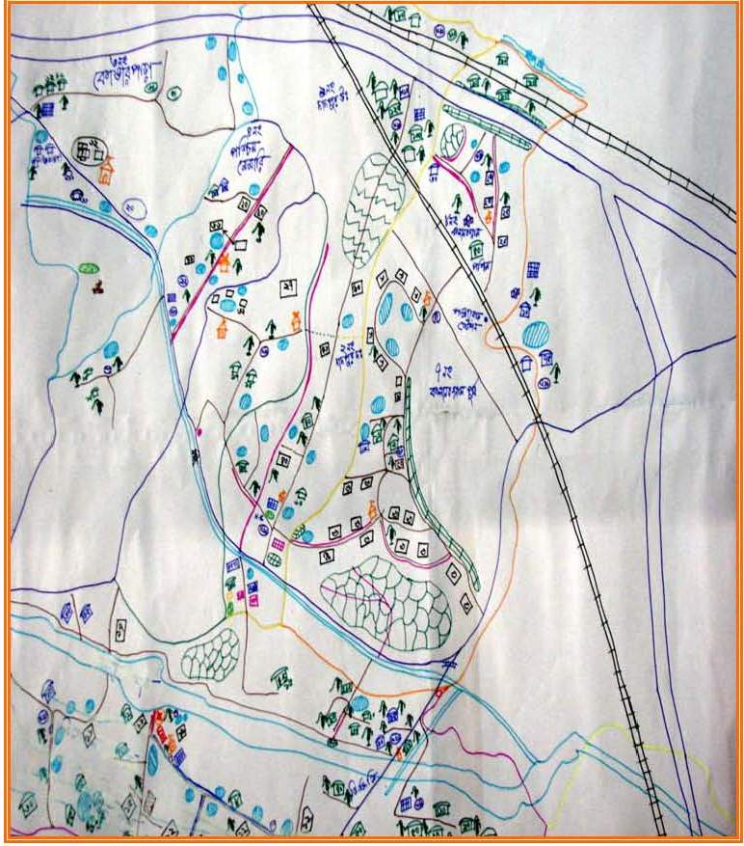
Based on the available primary information’s village level PRA maps depicting important land marks like schools, hospitals, etc along with drinking water sources will be prepared.

A PRA (Participatory rural Appraisal) is an intensive, systematic, but semi structured learning experience carried out in a community generally by multidisciplinary team with community members as primary actors.

The tools of PRA are the instruments that are used to gather, synthesize and analysis information in participatory way. The selection of tools and its development are done according to the objective of work and field situation.

9. Village Action Plan
 |  |  |  |  |  | from Community Meeting in consultation with PHED engineer(s)
S. No. | Description of water source/ scheme |  |  |  | Location |  | Capacity required (Liters per day) | Households |  |  | Financial |  |  |  |  |  | Sustainability |  | Responsibility
 |  |  |  |  |  |  |  |  | Estimated Capital Cost (Rs.) | Who pays for capital |  | IEC Training cost | Estimated O&M cost (Rs) | Who pays for O&M | Recharge measures | RWH measures | Community rules developed for the O&M of sources / schemes (Y/N) | Rules for management of sources and schemes (Y/N) | PHED | PRI | Community
1 | 2 |  |  |  | 3 |  | 4 | 5 | 6 | 7 |  | 8 | 9 | 10 | 11 | 12 | 13 | 14 | 15 | 16 | 17
A - Drinking water
1
2
3
4
5
Total

B - Other purpose water
1
2
3
4
Total

Legend for above table
Column No. | Description/Clarification
2 | Options: new source, repair existing, revive tradition source, rain water harvesting, treatment (household or community), etc
3 | Location based on community preference but technologically correct (as assessed by PHED)
4 | To ensure water security for every household
5 | For households benefiting from the intervention
7 | What is the funding source- NRDWP (including component), PRIs
9 | Community and/ or Government programme
10-11 | If yes, attach as annexure
12-14 | Examples: detailed design, final signoff on design and location, engage contractor, overall management of project, day to day oversight to ensure quality, O&M, collection of remuneration, long term management

