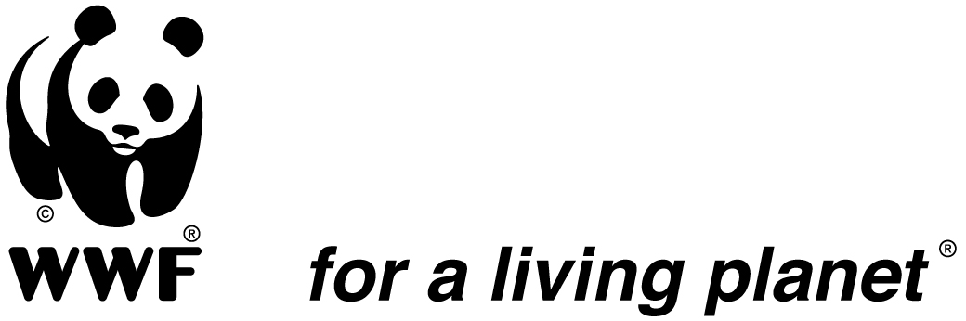

Climate Change Recommendations
2009 G8 and Major Economies Forum
July, 2009

Climate change is one of the symptoms of the richest countries in the world living beyond the planet’s means. However, both the economic and environmental crises teach us that there’s only so much debt that can be incurred before there are catastrophic consequences.

If the planet goes bankrupt, there can be no bailout.

The December Copenhagen UN Climate Change Conference – where the world must come together to address the challenge posed by climate change – is a little over 5 months away. At a time when the world faces an unprecedented economic crisis, the leaders of the richest countries must not forget their responsibility to commit to securing a fair, ambitious and science-based ‘Global Deal’ in Copenhagen. And they must grasp the opportunity to ensure that the economic recovery contributes positively to climate protection, rather than locking us into the high-carbon, unsustainable pattern of the present.

The G8 and MEF Summits in L’Aquila are a great opportunity for the world’s leaders to come together around joint initiatives to solve the three inter-related crises we are facing: the climate crisis, the economic crisis, and the poverty crisis. All of these crises need to be solved now, and agreeing strong commitments on climate change will be an important contribution both to protect hundreds of millions of the poorest people across the world against the devastating impacts of storms, droughts and floods, and to secure green jobs and sustainable investments that can deliver a way out of the economic crisis for all of us.

In particular the G8 countries have a standalone responsibility to show leadership. To do so the G8 communiqué must express that they are ready to take on the necessary deep emission reduction targets in the mid and long term and provide new and additional finance for low carbon development and adaptation to the developing world.

WWF calls on the leaders of the G8 and MEF countries to:

1. Commit to keeping temperature rise well below 2 degrees Celsius by moving on a low-carbon pathway

To keep the risk of catastrophic climate change acceptably low, global average temperature rise must be kept as far below 2 degrees Celsius as possible, compared to pre-industrial levels. G8 and MEF leaders must explicitly state their agreement to do what is necessary to ensure a high probability of staying well below 2 degrees Celsius. This will require a peak and decline of global emissions during 2013-2017, the next commitment period of the global UN climate deal to be agreed in Copenhagen. In 2050, global emissions will have to be cut by at least 80% below 1990 levels.

2. G8 commit to mid and long term reduction targets in line with staying well below 2 degrees warming

G8 leaders must commit to transform their economies to a low carbon pathway. Therefore, all G8 countries should publish before December a “zero carbon action plan” with ambitious mid-term targets and a long-term goal of truly de-carbonizing their economies by reducing emissions in 2050 by at least 95% below 1990 levels. It is urgent that long-term goals are clear in terms of their base year being 1990, to ensure comparability of effort between countries, recognition of early action and specificity with regards to the emission pathway required to stay well below 2 degrees C. For the mid-term, industrialized countries as a group should reduce by -40% compared to 1990 levels. In this context, the US will have to take on a comparable target in nature, legal form and effort.

3. G8 to give immediate adaptation funding for urgent adaptation needs in Least Developed Countries

The Least Developed Countries (LDCs) did not cause climate change but are among the most vulnerable to its impacts. The G8 leaders have a strong moral obligation to help increase the resilience of the poorest and create insurance-like mechanisms to cover costs of recovery from climate-change related disasters. G8 leaders should announce that they will provide $2 billion in funding this year for the National Adaptation Programs of Action (NAPAs) that have been completed by the least developed countries in the UNFCCC process. The least developed countries have completed the NAPAs in good faith, but while pledges have been made, funding has not yet been delivered.

This short term financing is urgently needed but must not in any way diminish or delay ambition to meet the urgent needs for long term adequate, predictable and reliable finance that is additional to ODA to meet the ever increasing costs of adaptation and to prepare for worst case scenarios where adaptation is no longer possible.

4. MEF countries to design pilot ‘Nationally Appropriate Mitigation Actions’ (NAMAs) and secure their immediate funding

In order to create the momentum for early and strong mitigation action in developing countries, the governments participating in the MEF should introduce the concept of ‘pilot NAMAs’, which should be fully financed by industrialized countries. These ‘pilot NAMAs’ should be designed to maximize opportunities for ‘learning by doing’ on NAMAs , and they should build confidence that a UNFCCC mechanism for mitigation in developing countries can work, and feed into the upcoming Copenhagen climate deal. The ‘pilot NAMAs’ will not imply any legally binding commitments by developing or developed countries. They will send a signal globally that developing countries are willing to introduce their actions in the UNFCCC process, and that industrialized countries are serious about their commitments to support those actions. Pilot NAMAs would be part of an approach that supports and builds the capacity of developing countries to put in place and implement development oriented “low carbon action plans” for a long term low-carbon vision of staying well below 2 degrees C.

5. Technology Action Programs as a way to ‘leap frog’ technologies and development

There is a growing consensus on the need to accelerate the development, transfer and diffusion of clean technologies. The EU, US, Japan, China and other major economies have all announced plans for increased public investment in research and development.
- The Copenhagen agreement can support this by mobilizing resources for international Technology Action Programs (TAPs). MEF leaders should endorse this and initiate work focusing on technologies of interest to developing countries, e.g. concentrated solar power, smart electricity grids, energy efficient buildings, systems for monitoring deforestation, early-warning weather stations.
- The level of research and development funding should be increased two-fold by 2012 and four-fold by 2020.
- Each TAP should explore options for dealing with issues around intellectual property rights to protect and share new technology and provide incentives for future innovation.

3. Financial Architecture to Implement Clean Energy Development, REDD and Adaptation

The MEF should identify the features of effective climate finance architecture as a key element of a Copenhagen climate deal, thus signaling to developing countries that their efforts will be supported:
- The MEF should assess a range of options for funding, including auctioning of assigned amount units or allowances and levies or auctioning from the international aviation and maritime sectors. The results of this assessment should be brought into the UNFCCC negotiations for conclusion in the context of a Copenhagen agreement.
- In WWF’s view the funding that needs to be provided by developed countries for ambitious actions on mitigation and adaptation in developing countries is in the order of USD 160 billion/year by 2017, largely through public finance. Emissions reductions achieved through such funding must be additional to ambitious emissions reduction targets from developed countries.
- In light of this level of ambition, it will be necessary to establish new institutions under the guidance and the authority of the UNFCCC to implement the finance and technology components of a Copenhagen climate deal. Existing institutions outside of the UNFCCC must also be reformed and transformed to contribute to the effort under the guidance of the UNFCCC and its new and strengthened institutions.

WWF Contacts:

Kim Carstensen  Leader, Global Climate Initiative  WWF International  Email: k.carstensen@wwf.dk  Mobile: +45 4034 3635 | Kathrin Gutmann  Head of Policy, Global Climate Initiative  WWF International  Email: kathrin.gutmann@wwf.de  Mobile: +49 162 29 144 28
Keya Chatterjee | Mariagrazia Midulla
Deputy Director Climate Change Program  WWF US  Email: keya.chatterjee@wwfus.org  Mobile: +1202 640-3451 | Head of Climate Change and Energy Programme  WWF Italy  Email: m.midulla@wwf.it  Mobile: +39 329 8316415

